
MEDIA ALERT

May 3, 2006
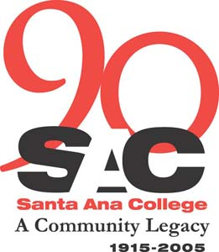

Criminal Justice Academies to host Career Opportunity Day

WHAT: According to the U.S. Department of Justice, employment in the law enforcement field continues to rise – there are over 8,000 open positions in law enforcement in the State of California today. Santa Ana College is home to 1,400 students from Orange County each semester who major in the criminal justice discipline. To increase interest and student success in this field, the SAC Criminal Justice Academies will host a Career Day.

FREE ADMISSION

WHO: Over 30 municipal, state and county law enforcement agencies from Orange and Los Angeles counties will be present to educate students and the community regarding entering the law enforcement field. Everyone will have an opportunity to network and research career opportunities in law enforcement.

WHERE: Santa Ana College
1530 W. 17th St.
Santa Ana, CA 92706
Free parking will be available.

WHEN: Wednesday, May 10
11 a.m. to 1:30 p.m.
BACKGROUND: The Criminal Justice Academies at Santa Ana College has one of the
finest reputations for law enforcement training in the nation. SAC has been affiliated with the Orange County Sheriff's Department since 1970 and provides training not only in the Basic Academy but also in many other advanced officer training classes catered to sworn police officers; deputy sheriffs; district attorney investigators, campus law enforcement and security; code enforcement officers; probation officers and others.

NEWS INTEREST: The Criminal Justice Academies of Santa Ana College, in conjunction with the Orange County Sheriff’s department, employ the latest technology and coordinate training programs for current sworn officers to meet their Peace Officers Standard and Training (POST) requirement of 24 hours. Their education at Santa Ana College is a continuous partnership for a successful career in the Criminal Justice field, and this event in another example that partnership.

PHOTO OPPORTUNITY: OC Sheriff’s dept. will demonstrate its Bomb Unit robotic technology

CONTACT: Ruth Cossio-Muniz, SAC Public Information Coordinator
Phone: (714) 564-6475, Mobile: (714) 401-7884

George Troxcil, SAC Criminal Justice Coordinator, (714) 628-5980.

