
NEWS

May 29, 2007

Contact: Dalilah Davaloz For Immediate Release
Public Information Office
Phone (714) 564-6475, Mobile (714) 623-8654
Davaloz_dalilah@sac.edu

A Passion for Nursing
A single mother of two accomplishes her goal of being a nurse.
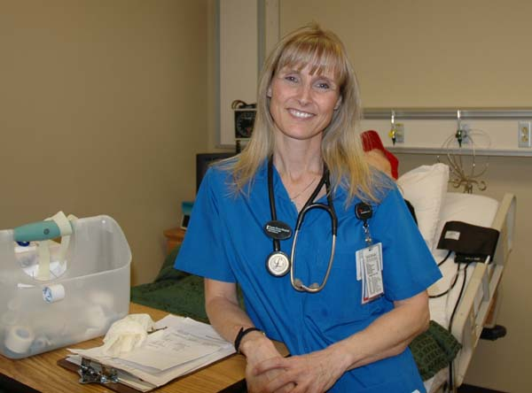
(Santa Ana, CA) – Diane Winchester knew she wanted to be a nurse at a young age. The single mother of two enjoys helping people and found time to volunteer as a hospice provider. After a few years of pursuing her studies, she completed the nursing program at Santa Ana College (SAC) and will join 57 graduates who are eligible to participate in the nursing pinning ceremony on Friday, June 1.
“When I chose nursing as a profession, I began to research programs,” said Winchester. “There were several programs available to me, but I selected SAC because it was a perfect fit, and it allowed me to continue to work and pursue my education.”
Winchester completed her general studies, and then moved on to complete her prerequisite courses prior to admittance into SAC’s nursing program. The nursing program consists of four semesters, and facilities are equipped with state-of-the-art equipment, including skills, simulation and computer labs.
The skills and simulation lab is designed similar to a hospital environment where digital mannequins are programmed to show certain symptoms allowing the student to assess and administer treatment to the patient. The lab environment is similar to a hospital, and students participate in scenarios followed by a debriefing. “The simulation lab scenarios provided me with an environment where I could react to the pseudo patient while gaining clinical exposure.”
- m o r e -

A Passion for Nursing Page 2 of 2

According to the Orange County Business Journal, Orange County is one of the largest employers of registered nurses, with 32 hospitals and 18 various hospital systems. However, an increased demand for hospital services and an aging workforce has contributed to an R.N. shortage. The 57 graduating students from SAC’s nursing program will be able to alleviate a portion of the nursing shortage.
The nursing program at SAC is accredited by the California Board of Registered Nursing and the National League for Nursing Accrediting Commission. The program is designed to qualify a student for the licensure examination and entry into practice as a registered nurse. Upon graduation from the program, students earn an associate’s degree in nursing.
Winchester has interviews set up with several hospitals, and will soon take her board exams. “I feel prepared after completing my program at SAC because it taught me to be confident.”
For information regarding the nursing program at Santa Ana College, please call (714) 564-6839.

About Santa Ana College
Santa Ana College is a public community college that serves nearly 50,000 credit and non-credit students annually. SAC provides education for academic transfer and careers, courses for personal and professional development, customized training for business and industry, and programs to train nurses, firefighters and law enforcement personnel.

# # #

