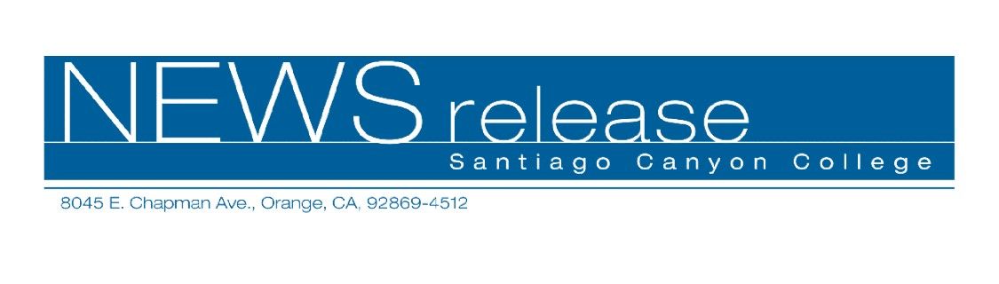
FOR RELEASE: IMMEDIATELY
CONTACT: ANNMARIE LIBRESCU
714-628-4745
librescu_annmarie@sccollege.edu

Free Digital Camera Classes Offered
May 3—Summer is just around the corner, full of graduations, weddings, vacations, and other occasions you’ll want to remember. It’s a great time to buy a digital camera or learn more about one you already have. Luckily, Santiago Canyon College’s Continuing Education program offers a FREE class on digital cameras to anyone 18 years and older. Learn everything from selecting a camera to taking great pictures and sharing them with friends and family. “Introduction to the Digital Camera” is conveniently offered on Tuesday evenings, Friday and Saturday mornings to fit into your busy schedule. Child care is also available.
Continuing education classes are designed to be started and stopped whenever you’d like. Helpful instructors make sure you’ll get the most out of the class, whether you attend once, twice, or weekly through June 3. “Introduction to the Digital Camera” provides introductory instruction on using digital still and video cameras. You’ll learn everything from selecting the right camera, basic camera features, taking great photos, transferring files from the camera to your computer, editing (“fixing”) photos, using your pictures and videos in websites and more, and outputting photos (printing, e-mailing, etc.). The course can be taken by itself or at the same time as other continuing education classes such as Adobe Photoshop or Adobe Premiere.
“Introduction to the Digital Camera” is offered from now until June 3 on Tuesday evenings from 6:00 to 9:00 p.m., Friday mornings from 11:00 a.m. to 2:00 p.m., and Saturday mornings from 8:00 to 11:00 a.m. Classes are held at the Orange Education Center, located at 1465 N. Batavia Street in Orange. Child care is available. For more information or to sign up, please call (714) 628-5900 or visit the web site at www.sccollege.edu/continuing_education.

--more--

Free Digital Camera Class Offered Page 2 of 2

Santiago Canyon College’s Continuing Education program offers free, non-credit classes (that don’t apply toward a college degree) to over 10,000 students each year. Subjects include English as a second language, business skills (computer classes), adult education, high school completion, GED preparation, citizenship and more.
Santiago Canyon College is a public community college of Rancho Santiago Community College District, serving the residents of Anaheim Hills, Irvine, Orange, Tustin and Villa Park. The college provides education for academic transfer and careers, courses for personal and professional development, and customized training for business and industry.

###

