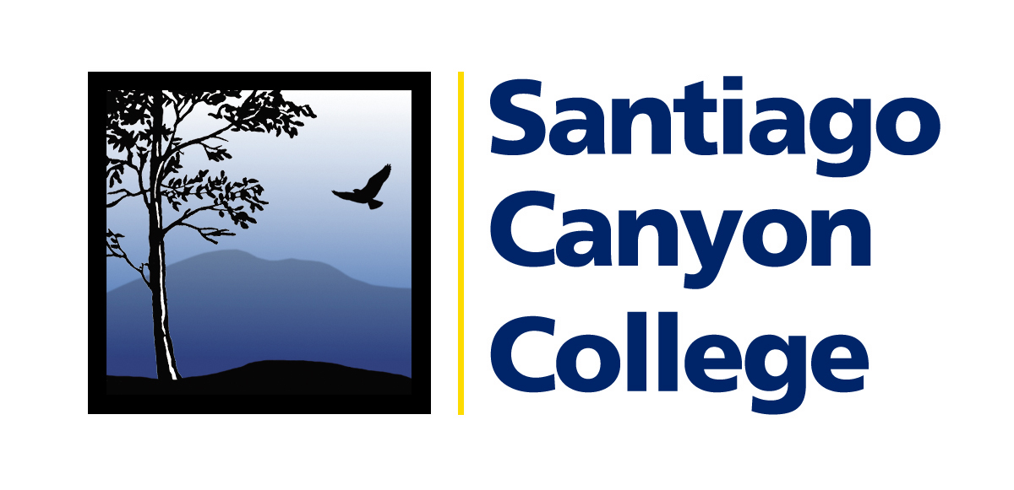

MEDIA ALERT

Media Contact: AnnMarie Librescu
(714) 628-4745 librescu_annmarie@sccollege.edu

Orange Education Center Hosts Student Appreciation Day

WHAT: On Thursday, June 1, Santiago Canyon College’s Orange Education Center (OEC) hosts its third annual Student Appreciation Day. Currently enrolled students will be treated to a free barbeque lunch or dinner. The public is invited to attend to learn about FREE summer classes and visit the beautiful 90,000 square foot, one-year new facility. Prize drawings will be held throughout the event.

WHEN: Thursday, June 1, 2006
10:00 a.m. to 12:30 p.m. and 7:00 to 9:00 p.m.

WHERE: Orange Education Center
1465 N. Batavia Street, Orange 92867

WHY: The Orange Education Center is one of the best kept secrets in Orange County! Home to Santiago Canyon College’s Continuing Education program, the dedicated faculty and staff at the OEC provide FREE classes to 10,000 people each year.

Summer classes begin June 12 and are open to anyone 18 years and older. Check out the summer class schedule online at www.sccollege.edu/continuing education. Choose from classes in computers (keyboarding, Windows, internet and many popular software programs), English, U.S. citizenship preparation, physical fitness, quilting, watercolor, writing your life story and much more. Classes are conveniently offered during the day, evenings and on Saturdays. These classes can be taken for fun, to learn new job skills or for career growth.

PRICE: FREE! Current students will receive a free barbeque lunch or dinner.

CONTACT: Rosemary Touyanou, Outreach Coordinator at (714) 628-5942 or e-mail to touyanou_rosemary@sccollege.edu.

