

NEWS
October 3, 2005

Contact: Ruth Cossio-Muniz

Communications Specialist For Immediate Release
Phone: (714) 564-6475
cossio_muniz_ruth@rsccd.org

Exercise Science Breaks Ground for a New Locker Room Complex

Santa Ana, CA – On Wednesday, October 12, Santa Ana College will host a groundbreaking ceremony at noon to mark the site of the new Exercise Science Locker Room Complex. The event, which will take place on the track field along College Avenue and 17th Street, will feature star student athletes, architectural renderings of the facility, and SAC alumnus and KOCE anchorman Ed Arnold. The public is invited to attend and can find free parking available in Lot 11. Light refreshments will be served.
Estimated at $14.4 million, this unique 22,000 square-foot building will replace the college’s age-old existing locker rooms, which currently serve approximately 4,000 students per semester in over 120 courses. The new complex will combine the locker room facilities to serve both men and women who participate in SAC’s 21 intercollegiate athletic teams and full range of exercise science classes. It will also consolidate instructional classrooms, equipment storage areas, faculty offices and conference rooms, which will be situated around the entry courtyard.
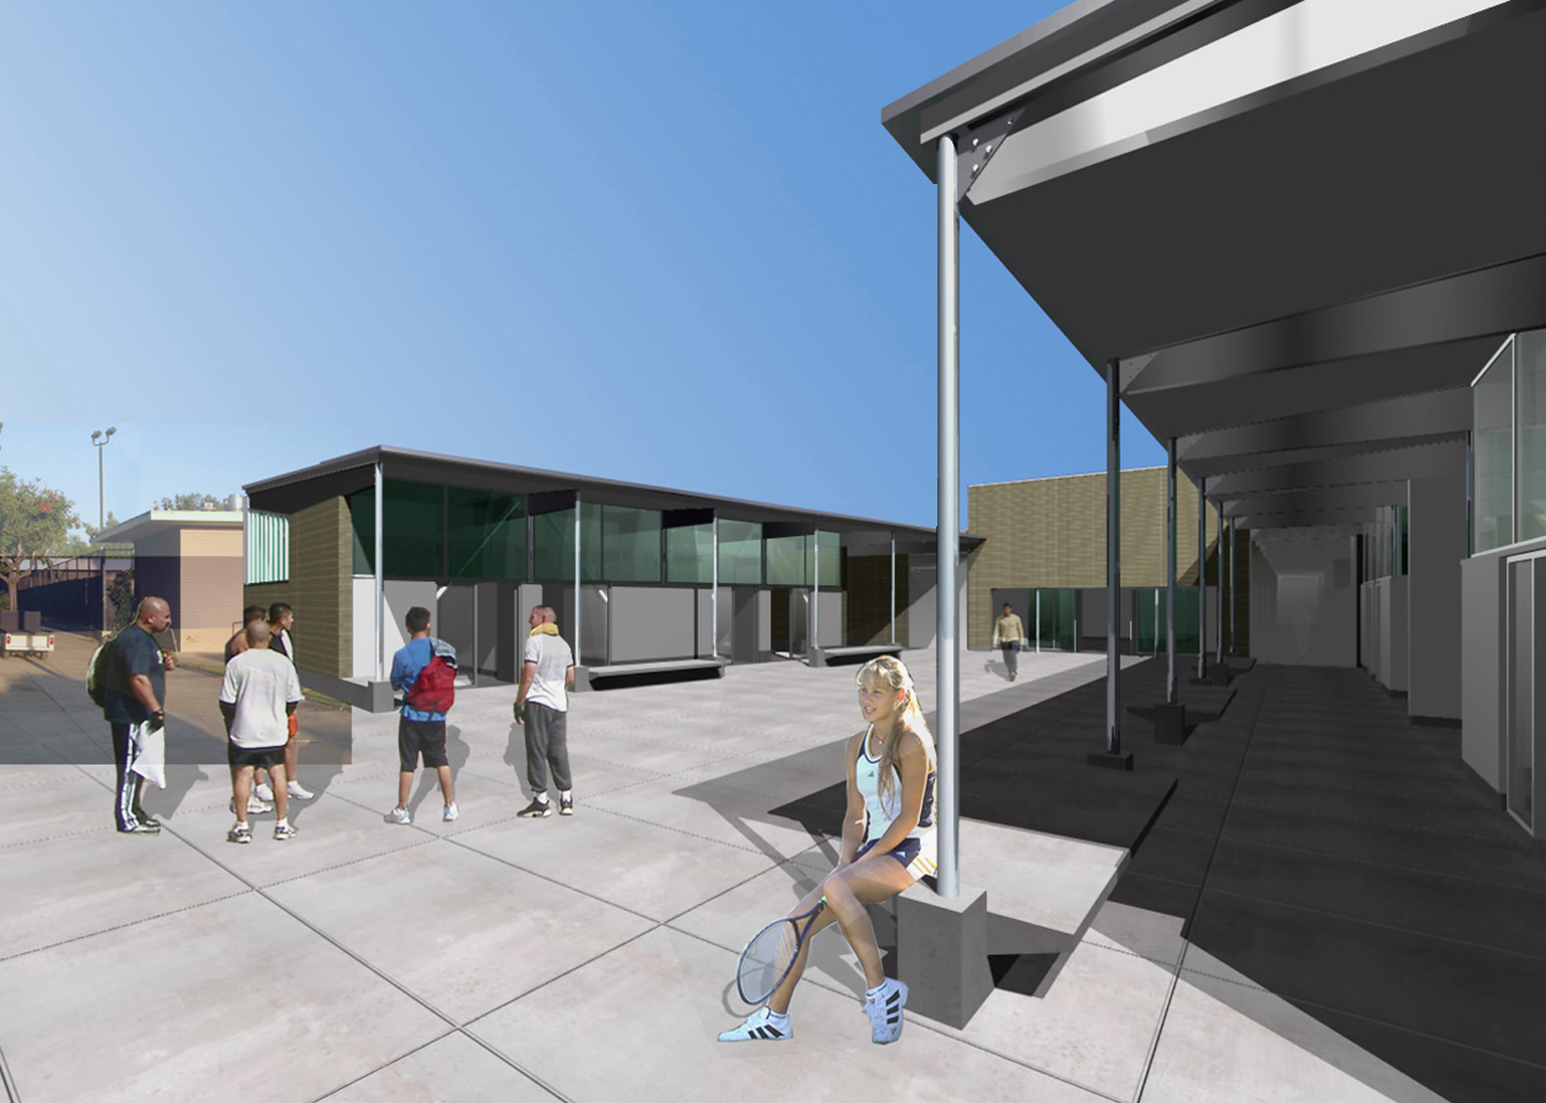

North entrance to the Exercise Science Complex.
Funds from Measure E, which voters approved in November 2002 providing $337 million for renovation and new construction at both Santa Ana College and Santiago Canyon College, will be used to construct the women’s locker rooms. The men’s locker room facility will be constructed using state funds. As one of California’s leading builders for K-12, community college and higher education works, C.W. Driver will manage the construction project scheduled to be completed entirely by spring 2007.
“The expansion and renovation of the exercise science division is a 20-year dream coming true for our students and the college community,” said Aracely Mora, dean of exercise science, health and athletics. “It wouldn’t surprise me if fireworks went off on the day of completion to demonstrate our excitement and gratification of this state-of-the-art facility.”
The complex will be the heart of the Exercise Science Division at Santa Ana College. Situated on the site of the existing men’s locker room building, it will directly serve the swimming pool, gymnasium, track and field, soccer and other athletic areas.
( more )

Santa Ana College Exercise Science Locker Room Complex Page 2 /2

The interior of the project will take on a light and open feeling by incorporating large amounts of glass to filter the natural light throughout the building. The design and engineering teams from Costa Mesa-based Thomas Blurock Architects were careful to ensure that all interior spaces were bathed in natural light, either from obscured glass surrounding the exterior walls or continuous skylights lining the interior corridors. The materials and colors selected for this project will bring an elegant, understated tone to the overall presence on the campus. The quality and articulation will be evident in this overall pallet of color, light and details.
Celebrating its 90th anniversary, Santa Ana College has a solid record of academic excellence, a rich tradition of building community partnerships and providing services to its students. SAC serves nearly 50,000 students annually in both credit and non-credit programs providing education for academic transfer and careers, courses for personal and professional development, and workforce training for business and industry.
For more information about the groundbreaking ceremony or new Exercise Science Locker Room Complex, please contact the Public Affairs and Governmental Relations Department at (714) 480-7500.
# # #

