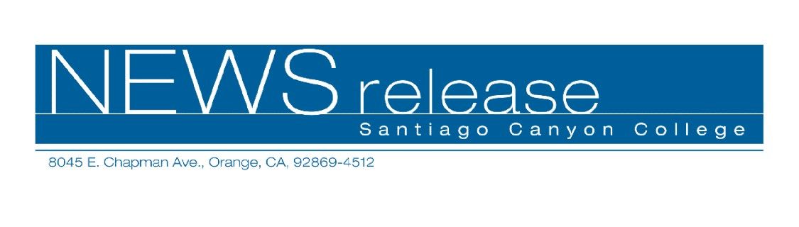
FOR RELEASE: IMMEDIATELY
CONTACT: ANNMARIE DEASY
714-628-4745
deasy_annmarie@sccollege.edu
Read, Write and Get Paid
September 28—Do you like to read in your spare time? Do you enjoy writing but don’t know how to get published? Learn how to turn these hobbies into money makers with a trio of classes offered by Santiago Canyon College’s Community Services program this Saturday, October 1.
A love of reading (and no other experience) is required for the “Read All Day and Get Paid For It” class offered from 9:00 a.m. to 12:00 p.m. Award-winning writer, producer and educator Jack Adams provides entertaining instruction in finding jobs reading and reporting on materials of your choice: scripts, newspapers, magazines, manuscripts, plays and more. Part or full-time work is available in the field with flexible schedules. “Read All Day and Get Paid For It” will be held on October 1 at Santiago Canyon College, building B, room 211. The cost is $44 plus a $3 material fee (payable in class).
Jack Adams also teaches “Writing for Magazines,” an overview of how to start a freelance writing career easily with submissions to magazines. Learn how to find what you need, who to approach (and how), scams to avoid, and more. The class is on Saturday, October 1 from 1:00 to 4:00 p.m. in B-211 at a cost of $44.
Discover over 100 ways to make money as a freelance writer with “A Beginner’s Guide to Getting Published.” You’ll learn how to submit manuscripts the correct way and write query letters that
--more--
Read, Write and Get Paid Page 2 of 2

editors will find irresistible. The class is taught by LeeAnne Krusemark, an author, journalist, and owner of an award-winning public relations business. It will be held on Saturday, October 1 from 10:30 a.m. to 1:00 p.m. at Santiago Canyon College, building B, room 212. The cost is $39 plus a $10 material fee payable at the door.
The college is located at 8045 E. Chapman Avenue in Orange. To register, obtain more information or get directions, call (714) 628-4960 or visit the web site at www.sccollege.edu/cs.
Santiago Canyon College is a public community college of Rancho Santiago Community College District, serving the residents of Anaheim Hills, Irvine, Orange, Tustin and Villa Park. The college provides education for academic transfer and careers, courses for personal and professional development, and customized training for business and industry.
###

