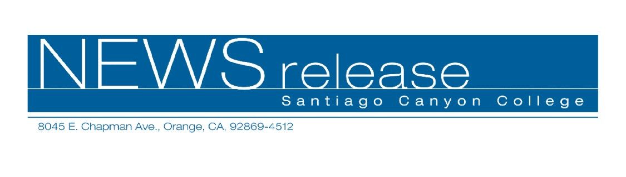
FOR RELEASE: IMMEDIATELY
CONTACT: ANNMARIE LIBRESCU
714-628-4745
librescu_annmarie@sccollege.edu
Disneyland Selects Santiago Canyon College’s Collegiate
Choir to Participate in Annual Candlelight Procession

November 1 – As night falls over Disneyland Resort on December 2, the warm glow of candlelight will brighten Main Street U.S.A. and the voices of a 700-person choir will fill the air marking the start of Disneyland’s annual Candlelight Procession. Among the musical voices will be the Santiago Canyon College (SCC) Collegiate Choir, which was hand-picked by Disney to participate.
“This is the first time that a choir from SCC has been selected to participate in this amazing event,” said choir director Michael Short. “We are very excited to be part of such a huge tradition and honored to participate in the Candlelight Procession during Disney’s Year of a Million Dreams.”
The Disneyland Candlelight Procession and Ceremony includes narration of the classic Christmas Story by a celebrity guest, along with a full orchestra. The chorale ensemble is made up of Disney cast members and more than 30 different choirs from throughout Southern California and as far away as Las Vegas, Modesto and the San Francisco Bay area.
-more-

SCC Choir to Participate in Disneyland “Candlelight Procession” 2 of 2
SCC’s Collegiate Choir was formed just two years ago and features a talented ensemble that has performed at community events such as the SCC Library dedication, spring concerts including “A Night of Opera,” and much more.
Santiago Canyon College is a public community college of Rancho Santiago Community College District serving the residents of Anaheim Hills, Irvine, Orange, Tustin and Villa Park. The college provides education for academic transfer and careers, courses for personal and professional development, and customized training for business and industry.

# # #

