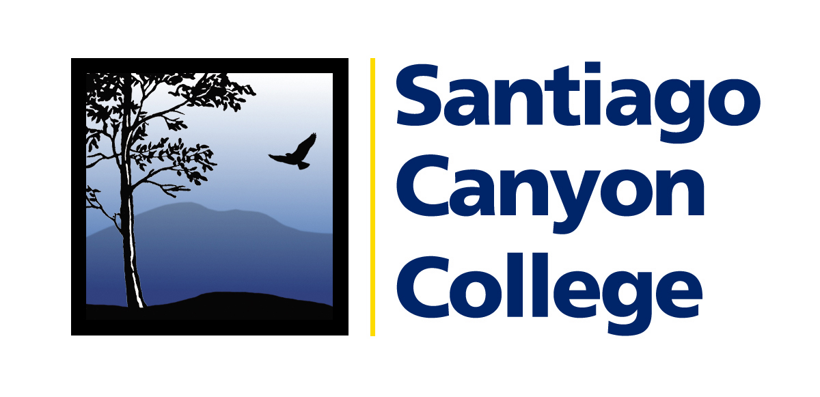

CALENDAR LISTING

Contact: AnnMarie Librescu
Phone: (714) 628-4745
E-mail: Librescu_annmarie@sccollege.edu

LEARN SPANISH AND EARN COLLEGE CREDIT IN

PLAYA DEL CARMEN, MEXICO

WHAT: Students have the opportunity to travel to the Mexican Caribbean this summer with Santiago Canyon College’s Spanish Language program. Students will learn Spanish among the beaches of Playa Del Carmen, Mexico, located in the heart of the Mayan Riviera. Participants can receive five or 11 units of college credit (depending on placement level) and can enroll in beginning, advanced and/or conversational Spanish courses held Monday-Friday at El Estudiante School. Students will stay with host families during this five-week Spanish immersion program.

WHO: The program is open to anyone interested in learning Spanish, including college
and university students and members of the community.

WHERE: Playa Del Carmen, Mexico.

WHEN: June 21-July 28, 2007. The next informational meeting is Thursday, March 15 at SCC.

PRICE: A $450 deposit is due April 12.

CONTACT: Dr. Elizabeth Baez, (714) 628-4742, baez_elizabeth@sccollege.edu. For additional information, call (714) 628-4820.
# # #

Santiago Canyon College is a public community college of Rancho Santiago Community College District serving the residents of Anaheim Hills, Irvine, Orange, Tustin and Villa Park. The college provides education for academic transfer and careers, courses for personal and professional development, and customized training for business and industry.

