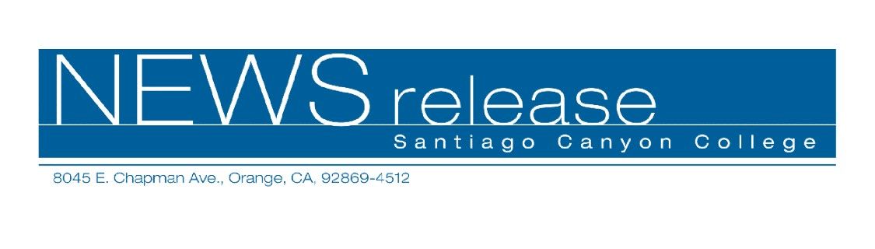
May 27, 2010
For immediate release
Contact: John Weispfenning
714-628-5030
Weispfenning_John@sccollege.edu
Santiago Canyon College Holds
Eleventh Annual Commencement

Orange—Santiago Canyon College (SCC) holds its eleventh annual commencement exercises on Friday, June 4, at 4:30 p.m. on campus at Strenger Plaza. This year, 810 students are eligible to graduate. The graduates range from 18-62 years of age.
The Class of 2010 valedictorian is Kimberly Lucas, a 19-year-old resident of Orange. She graduates with an associate degree in liberal arts with an emphasis in arts, humanities and communication and a 4.0 grade point average. She has earned highest honors, is a President’s Scholar and is a member of Santiago Canyon College Honors Program. Kimberly is planning to continue her studies in children’s literature at Pomona College, UCI or UCLA.
This year’s salutatorian (the second-highest ranked student in the graduating class) is Tak Yin Wong, who also graduates with a 4.0 grade point average and highest honors. He graduates with an associate degree in liberal arts with an emphasis in mathematics and sciences. He is a President’s Scholar and a member of both the Santiago Canyon College Honors Program and Phi Theta Kappa. The 21-year-old Orange resident is planning to attend the University of California, Berkeley in the fall, where he plans to study economics. Tak’s goal is to become a successful entrepreneur.
“This is an outstanding graduating class,” said Santiago Canyon College President Juan Vázquez. “The students in the class of 2010 have made their mark on our campus. On behalf of college faculty, staff and administrators, I wish each and every graduate much success in the future.”

-MORE-

SCC 11th Annual Commencement
May 27, 2010
Page 2

This year’s commencement speaker (determined by student vote) is James V. Granitto, assistant professor of philosophy. He has taught in community colleges for 23 years and has been at Santiago Canyon College since 2006. A former chair of the American Philosophical Association’s Committee on Philosophy at Two-Year Colleges, he is a co-advisor of SCC’s Philosophical Society and the Political Science Forum. He is an active member of the college community, serving on the Academic Senate and its committees.
More than 1,200 people are expected to attend the commencement ceremony on June 4, including graduates, friends and families. A photo area for graduates will be available in the A/B Quad following the ceremony.
Santiago Canyon College is a public community college of Rancho Santiago Community College District, serving the residents of Anaheim Hills, Orange, Tustin and Villa Park. The college provides education for academic transfer and careers, courses for personal and professional development, and customized training for business and industry.

# # #

