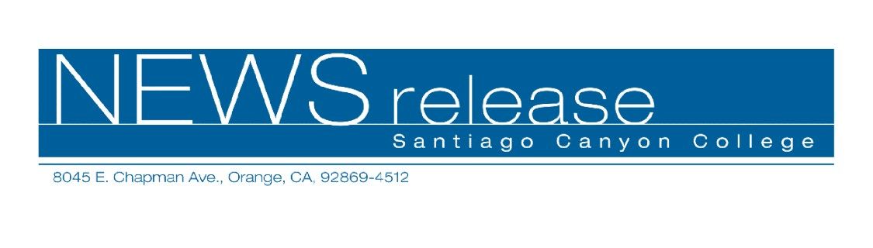
FOR RELEASE: IMMEDIATELY
CONTACT: ANNMARIE LIBRESCU
714-628-4745
librescu_annmarie@sccollege.edu
Self-Defense Training Important for Kids
March 22—All parents wants to keep their children safe from danger and shield them from harm. Unfortunately, you can’t be with them all the time. Do your children know how to protect themselves when approached by schoolyard bullies or strangers? Make sure by signing them up for “Self-Defense Techniques for Kids,” a class for 8- to 12-year-olds offered by Santiago Canyon College’s Community Services program. The class will be held on Friday, March 31 from 4:00-6:00 p.m.
“Self-Defense Techniques for Kids” teaches children important lessons that could one day save their lives. They’ll learn how to protect themselves against bullies, take control if they are pushed to the ground, and exercise precaution with strangers. At the same time, they’ll build self-confidence, self-respect and learn “street smarts.”
The class instructor is Jesse Anderson, who has nearly 20 years experience in martial arts training. He has been teaching self-defense techniques since 1994.
The fee for “Self-Defense Techniques for Kids” is $36 per child. The class will be held on Friday, March 31 from 4:00-6:00 p.m. at Santiago Canyon College, room D-125. The college is located at 8045 E. Chapman Avenue in Orange. To register, obtain more information or get directions, call (714) 628-4960 or visit the web site at www.sccollege.edu/cs.
Santiago Canyon College is a public community college of Rancho Santiago Community College District, serving the residents of Anaheim Hills, Irvine, Orange, Tustin and Villa Park. The college provides education for academic transfer and careers, courses for personal and professional development, and customized training for business and industry.

###

