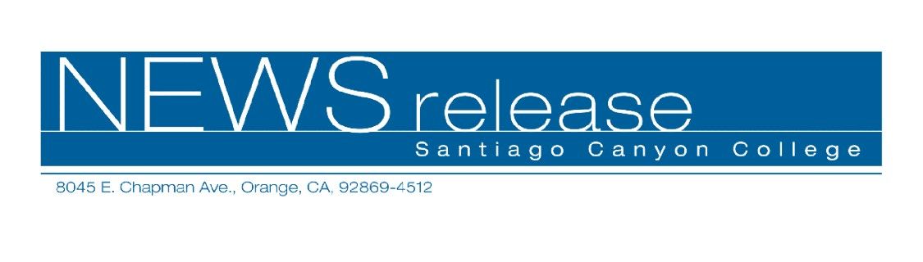
December 7, 2009
For immediate release
Contact: John Weispfenning
714-628-5030
Weispfenning_John@sccollege.edu
Soccer Lady Hawks Win State Title

Orange—The Santiago Canyon College (SCC) women’s soccer team finished the season undefeated by winning the state community college championship Sunday, December 6, in Sacramento.
SCC ended the season with a 23-0-2 overall record.
The Lady Hawks defeated Cosumnes River College, 1-0, for the title. The match was played on the Cosumnes campus.
“There were some challenges,” said SCC head coach Ian Woodhead. “They had the home field, the home crowd. They had a lot of things in their favor.”
The first half was uneventful. SCC’s offense began to generate scoring opportunities early in the second half, but was unable to convert. In the 68th minute, SCC’s Amanda Hardeman scored the only goal of the match.
The Lady Hawks had advanced to the championship with a 3-2 win over American River College on Friday in the semi-finals. This was the Hawks’ third appearance in the final four in four years.
The Hawks also ended the season ranked first in the nation in the National Soccer Coaches Association of America Division III poll.
“The undefeated bit is always nice,” Woodhead said.
SCC’s earlier playoff wins came against Santa Ana College, Cerritos College, and Moorpark College.

-MORE-

Santiago Canyon College
Women’s Soccer – Page 2

Santiago Canyon College is a public community college of Rancho Santiago Community College District, serving the residents of Anaheim Hills, Orange, Tustin and Villa Park. The college provides education for academic transfer and careers, courses for personal and professional development, and customized training for business and industry.

# # #

