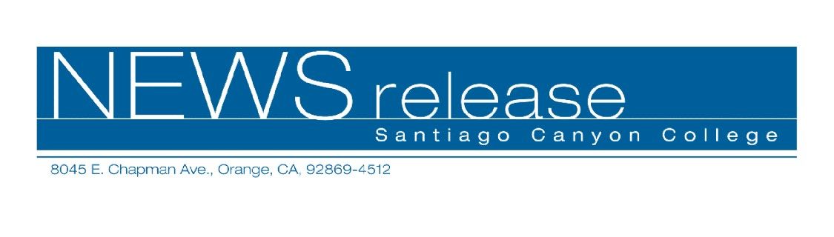
FOR RELEASE: IMMEDIATELY
CONTACT: ANNMARIE DEASY
714-628-4745
deasy_annmarie@sccollege.edu
Santiago Canyon College Offers a Life Saving Class

July 22—Because lives can be saved by correctly performing CPR, every person should know how and when to use it. This summer, Santiago Canyon College’s Community Services Program invites participants, ages 16 and older, to become CPR certified in a one-day class.
CPR for Adults, Children and Infants meets Saturday, July 30 from 9 a.m. to 1 p.m. in Santiago Canyon College B-210. The cost is $54, with a $10 material fee payable at the door.
Developed in the 1960s, CPR stands for cardiopulmonary resuscitation, a combination of mouth-to-mouth resuscitation and chest compressions. Through the use of CPR, oxygen-rich blood can be re-circulated to the brain. Without oxygen, permanent brain damage or death can occur in less than eight minutes. Benefits of CPR may include the prevention of SIDS (sudden infant death syndrome) and the reduction of cardiac arrest deaths. Participants will learn: how to respond to cardiac or respiratory arrests, single rescue CPR for adults, children and infants, and airway object removal techniques.
Jack Griswold, a college instructor and member of the Western U.S. Regional faculty for the American Heart Association, will be teaching this class.
To register for CPR for Adults, Children and Infants, contact the community services program office at (714) 628-4960 or visit us online at www.rsccd.org/cms.
Santiago Canyon College is located at 8045 E. Chapman Avenue in Orange, at the corner of Chapman and Newport. It is a public community college of Rancho Santiago Community College District serving the residents of Anaheim Hills, Irvine, Orange, Tustin and Villa Park. The college provides education for academic transfer and careers, courses for personal and professional development, and customized training for business and industry.
###

