Rancho Santiago Community College District (RSCCD) is evaluating alternative medical plan options to ensure employees are provided access to the most comprehensive and cost-effective medical coverage. This memorandum was designed to provide insight into the comparison of the Aetna alternatives as compared to the current benefits offered by Anthem Blue Cross through ASCIP.
Comparison of Medical Plan Offers
The evaluation of the Aetna vs. Anthem medical plan offerings was focused on the following three areas to identify and understand potential disruption to RSCCD employees.
- Plan Design: Determine that RSCCD employees would continue to receive at least the same level of benefits or increase coverage levels.
- Provider Access: Identify the medical groups utilized by RSCCD employees and evaluate any disruption to provider access that would occur under an alternative medical plan.
- Cost of Plan: Identify and quantify the potential fiscal impacts of the alternative medical options as compared to the current renewal offer from Anthem Blue Cross.
Aetna Offer
Aetna has proposed the following alternatives to the current Anthem Blue Cross HMO and PPO plan for RSCCD employees:
- Two (2) HMO Offerings: Aetna has proposed the below HMO offerings for consideration by RSCCD.
  - Full Network HMO – The Full Network HMO has been designed to match or exceed the current benefits offered under the Anthem Blue Cross HMO and will access to the largest national network offered by Aetna.
  - Whole Health HMO – The Whole Health HMO is designed around a high-performance network that allows Aetna to provide this option at significantly lower premium cost in addition to reducing the physician, specialist, and urgent care co-pays to $5 to reduce out-of-pocket spend for employees. This network includes approximately 38% of the current medical groups that are attended by RSCCD employees.

- One (1) PPO Offering: Aetna has proposed the below PPO offering for consideration by RSCCD.
  - Open Access Managed Choice (OAMC) PPO 90/70 – The OAMC PPO 90/70 has been designed to match or exceed the current benefits offered under the Anthem Blue Cross PPO and will access the largest national network offered by Aetna.
Comparison Area #1: Plan Design
Included as an attachment to this memorandum is the detailed comparison of plan designs (e.g. co-pays, deductibles, co-insurance, etc.) between the Aetna plans options and the corresponding Anthem plans currently offered. For ease of understanding, we have highlighted any areas of increased benefit in green and any areas of reduced benefit in red.
Wellness Allowance - In addition to the benefits included in the plan design comparison Aetna has offered a $50,000 wellness allowance to RSCCD that could be utilized to help fund wellness and health related activities across the different college campuses.
Comparison Area #2: Provider Access
Aetna has performed a comparison of the current medical groups utilized by the RSCCD employees and has provided the following statistics to ensure transparency regarding disruptions employees may experience in a transition from Anthem.
- Full Network: 100% of the medical groups utilized under the Anthem plan currently contract with Aetna for their Full Network.
- Whole Health Network: 37.9% of the medical groups utilized under the Anthem plan currently contract with Aetna for their Whole Health Network
It is important to note that RSCCD would offer both the Full Network and Whole Health Network options for employees to select from. If RSCCD employees can identify their current medical groups/providers in the Whole Health Network they would have the opportunity to select the high-performance HMO plan to access the lower co-pays and out-of-pocket plan design.
Provider Search - For those who are seeking to search for their providers the following links can be utilized.
- Full Network HMO: https://www.aetna.com/dsepublic/#/contentPage?page=providerSearchLanding&site_id=DirectLink&planValue=MHMO%7CHMO
- Whole Health HMO: https://www.aetna.com/dsepublic/#/contentPage?page=providerSearchLanding&site_id=DirectLink&planValue=SCAHM%7CAWH_Southern_CA_HMO
- OAMC 90/70 PPO: https://www.aetna.com/dsepublic/#/contentPage?page=providerSearchLanding&site_id=DirectLink&planValue=OAMC%7CManaged_Choice_POS_Open_Access
If you are unable to find your specific provider it may be due to the fact that they are not currently accepting new patients or may be filed under a different name. In this case, you can reach out to Diane Loya and she will put you in touch with resources to help verify that your doctor is in the plan.
Comparison Area #3: Cost of Plan
During the comparison of costs, RSCCD evaluated the renewal offer from Anthem Blue Cross for the existing plans against the Aetna rates offered within their proposal. Below is a summarization of the percentage impact followed by the total dollar impact. The total dollar impact has been broken out between Actives vs. Early Retirees.

The Cost of Plan information represented below are rates charged to the district and do not reflect any out-of-pocket costs to the employee. Each bargaining group has negotiated contributions for their members and most employees do not pay any portion of the premium costs. For further detail on the impact to employee out-of-pocket costs please check in with your Joint Benefits Committee representative.

Entity | % Increase over Current Cost | Year #2 Rate Cap
Anthem Blue Cross | 7% | None
Aetna Proposal #1 | 1% | None
Aetna Proposal #2 | 3% | 9.8% Rate Cap

HMO: Premium Cost Comparison for Active Employees
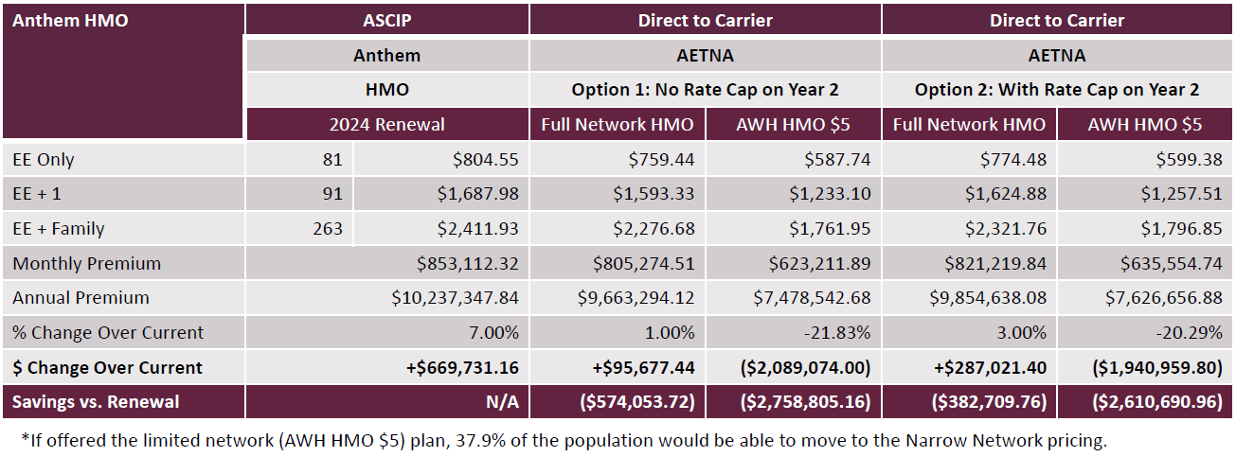
HMO: Premium Cost Comparison for Early Retiree
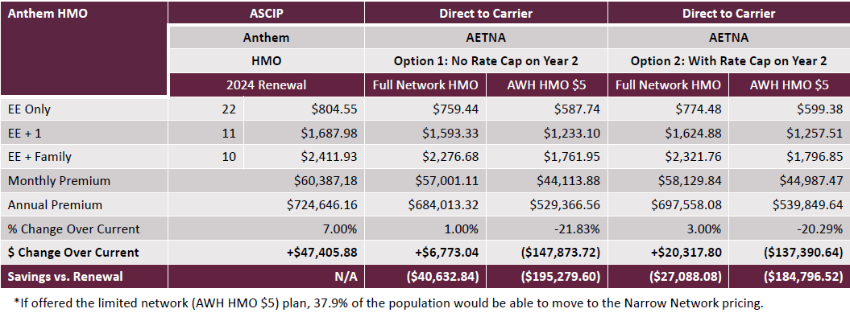

PPO: Premium Cost Comparison for Active Employees
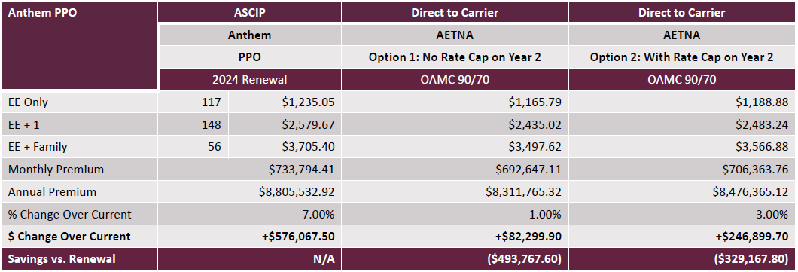
PPO: Premium Cost Comparison for Early Retirees
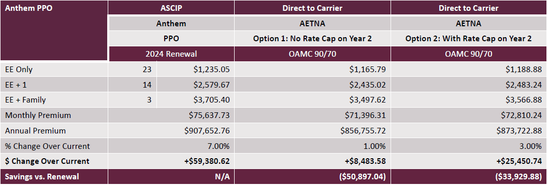
Summary of Estimated Savings
The below table highlights the aggregated estimated savings. There is a range of savings shown for each of the Aetna options based on the level of enrollment into the Whole Health high-performance network HMO option. Thus, the Total Estimated Savings should be considered as a range of potential savings for RSCCD.
