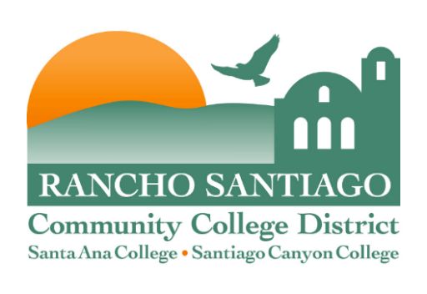
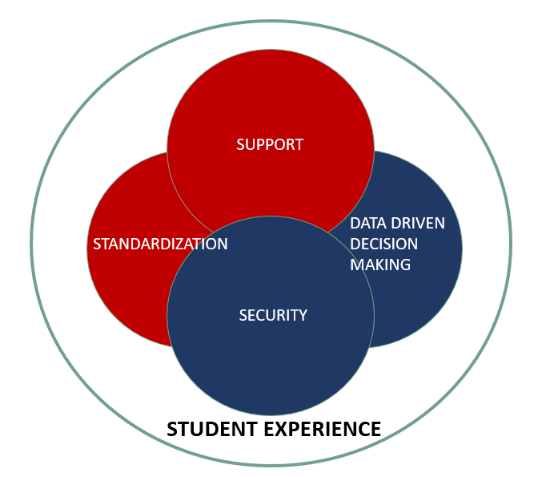Strategic Technology Plan
2021 – 2025

Board Approved: December 14, 2020
Last updated by TAG: May 2, 2024
Contents
Purpose 3
Executive Summary 3
Strategic Planning Framework 4
1. Strategic Themes 4
2. Goals 4
3. Initiatives 4
4. Projects 4
Using the Strategic Planning Framework to Support the Delivery of Technology Districtwide 5
Using the Strategic Planning Framework to Develop Strategic Technology Plans. 6
Strategic Planning Process 8
External environment analysis 8
Internal environment analysis 11
Putting it all together: Developing Strategic Themes for Technology 14
Strategic Themes 2021-2025 22
Goals 2021-2022 23
1. Student Experience 23
2. Standardization 23
3. Data Driven Decision Making 23
4. Security 24
5. Support 24
Goals 2023-2025 25
1. Student Experience 25
2. Standardization 25
3. Data Driven Decision Making 25
4. Security 26
5. Support 26
Districtwide Initiatives 2020-2021 27
Districtwide Initiatives 2021-2022 29
Districtwide Initiatives 2022-2023 31
Districtwide Initiatives 2023-2024 33
Districtwide Initiatives 2024-2025 35
Implementing the plan: Technology Decision Making and IT Governance 37
Measuring the success of the Strategic Technology Plan 38

Purpose
The purpose of the Strategic Technology Plan (STP) is to establish an informed framework for decision making that guides and supports the effective use of technology districtwide for the next four years. The STP considers current internal and external environmental conditions, accreditation standards defined by the Accrediting Commission for Community and Junior Colleges (ACCJC), and the goals established by the District’s Strategic Plan and the Colleges Educational Master Plans. These elements are aligned to produce a flexible hierarchical planning structure around current technology trends in support of the institutional mission of the district and its colleges. The STP is a living document, with flexible planning elements that are regularly reviewed and updated to ensure it remains relevant with institutional goals and an evolving technology landscape.

Executive Summary
Student success is the cornerstone and anchoring foundation for this Strategic Technology Plan (STP). Global research continues to show driving student success as a common objective across higher education institutions across the world. The core element of the Vision for Success, developed by the California Community Colleges State Chancellor’s Office, is “making sure students from all backgrounds succeed…” and the Guided Pathways framework has been established to accomplish this goal. Focusing on student achievement and completion are part of the goals of the Educational Master Plans for both Santa Ana College and Santiago Canyon College as well as the Rancho Santiago Community College District Strategic Plan. Information technology, being a key institutional asset, plays a critical role to drive student success. As such, this STP establishes a decision-making framework built around student experience as the main strategic theme that sits at the center of all technology strategy, and as a catalyst for student success.

Current technology trends in higher education and the district and colleges goals and objectives require a number of additional supporting elements to be established in order to support student experience through technology for the next four years. These elements are grouped together under four strategic themes: standardization, data driven decision making, security and support. Standardization is used to create efficiencies across the institution; data driven decision making to measure and predict outcomes; security to protect institutional data and student privacy and support to enable classroom technology, smart campus innovations and back office technology. These four supporting strategic themes, along with the main strategic theme of student experience, are used to derive districtwide technology two-year goals in alignment with ACCJC accreditation standards. These goals, in turn, drive districtwide and college specific technology initiatives for the academic year, which guide the projects executed by operational areas districtwide.

The institution uses an established technology decision making process to implement this STP and biannual reporting to measure success and provide the opportunity for adjustment and fine-tuning.

Strategic Planning Framework
In the Spring of 2019, a group of representatives from TAG, SACTAC and SCCTEC pursued an initiative to establish a districtwide technology planning framework in order to better align the College and Districtwide Strategic Technology plans and streamline the planning process. The group assessed proven technology planning frameworks used at other California Community Multi-College Districts. The group settled on a planning framework used by San Jose Evergreen Community College District, which has been adopted by Yuba Community College District and the Chief Information Systems Officers Association (CISOA). This planning framework considers internal and external environment conditions, accreditation standards and the goals established by the District’s Strategic Plan and the College’s Educational Master Plans. The end result is a hierarchical planning structure that includes three planning layers: Strategic Themes, Goals and Initiatives and an operational execution layer: Projects.

Strategic Themes
Strategic Themes is the highest strategic layer in the planning framework. Strategic Themes are intended to be brief, high level, broad, long lasting, all-encompassing and a reflection of the external and internal environments. Strategic Themes are derived from an assessment of the current technology trends in the higher education space and the California Community College System, the District’s Strategic Plan and the College’s Educational Master Plans. Developing Strategic Themes is the first step in the planning process.

Goals
Goals are derived from the Strategic Themes. Goals are lower level, more specific and aligned with Technology Accreditation Standards. Goals take more of the internal institution environment districtwide into account when developed.

Initiatives
Initiatives are derived from the Goals. Initiatives are low level, specific and based on a more detailed analysis of institutional technology needs. Initiatives can occur at a districtwide or college specific level. Initiatives represent the bridge from planning to execution. Participatory groups are to involve operational workgroups in the development of initiatives. Operational workgroups are to align project requests with initiatives and prioritize based on their support to the planning framework.

Projects
Projects are the lowest common denominator. The Project layer is not part of the planning process, rather, it’s its result. Projects are derived from initiatives; they are the lowest level items, very specific and cannot be broken up any further. Projects can occur at a districtwide or college specific level. Projects are generated in several ways, including but not limited to, by institutional stakeholder requests, external mandates or statewide initiatives to name a few. District operational workgroups are in charge of ensuring that project requests are properly aligned with the initiatives in the Strategic Technology Plan, that they are prioritized based on their positive institutional impact and that they are timely executed in support of the Strategic Technology Plan.

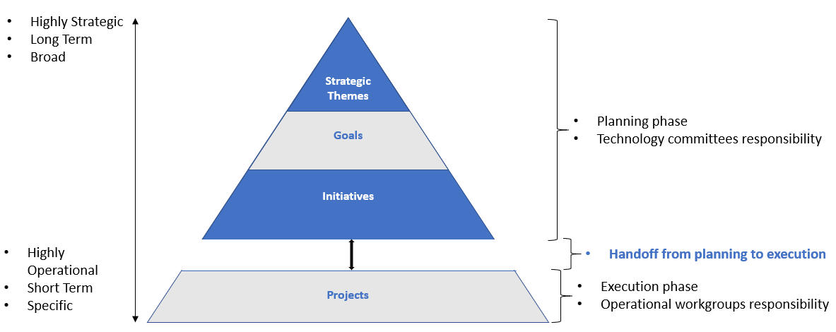
Figure 1 Hierarchy of Planning Framework

Using the Strategic Planning Framework to Support the Delivery of Technology Districtwide
The Strategic Planning Framework guides operations to ensure technology is delivered in support of institutional strategy. In addition, the Framework creates a feedback loop between technology committees, who are in charge of planning, and operational groups, who are in charge of executing. This occurs by establishing an informational process in which outcomes are communicated between these two groups. Communication is critical to determine the success of the Framework. Planning groups need to be aware of what is being executed and operational groups need to know what is being planned. This level of communication allows fine tuning to occur, which supports continuous improvement.

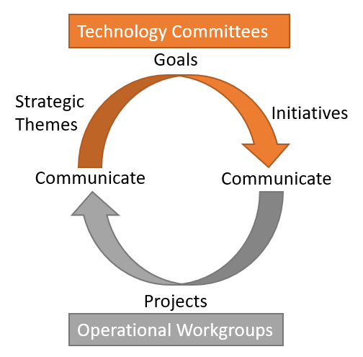
Figure 2 Technology Planning and Execution Cycle

Using the Strategic Planning Framework to Develop Strategic Technology Plans.
The Strategic Planning Framework ensures that there is thorough alignment in all Technology Plans districtwide. The same Strategic Themes and Goals are applicable to the Master, SAC and SCC Technology plans. Districtwide initiatives are captured in the Master Strategic Technology Plan developed by TAG, while College specific initiatives are included in the College Technology plans developed by SACTAC and SCCTEC.
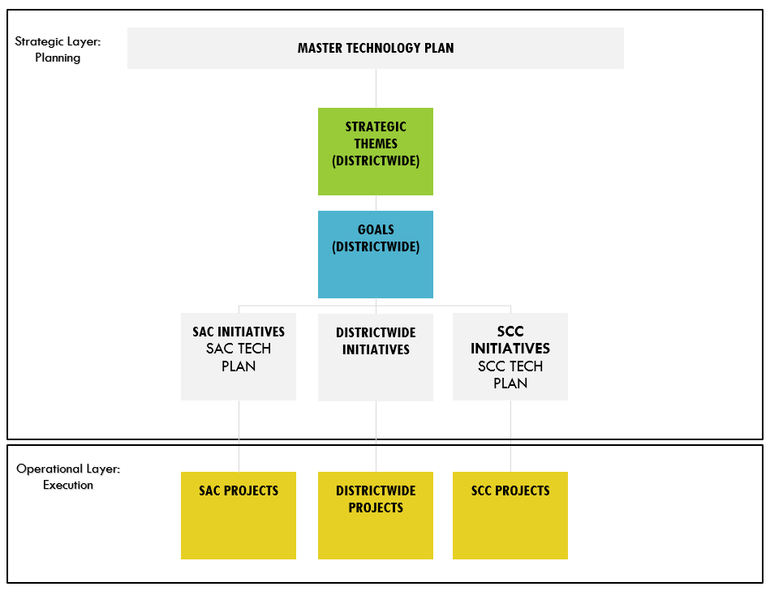
Figure 3 Strategic Technology Plan Structure

Strategic Elements Duration and Review:
Strategic Themes, being broader and longer term are designed to last longer than every other element. The timeframes shorten further down the hierarchy tree:

Strategic Element | Validity Duration | Validity Period | Review Responsibility | Review Period
Strategic Themes | 4 Years | January 1st, 2021 to  June 30th, 2025 | Technology committees | Every 4 years
Goals | 2 Years | January 1st, 2023 to  June 30th, 2025 | Technology committees | Every 2 years
Initiatives | 1 Year | July 1st to June 30th | Technology committees | Every year
Projects | As needed to complete | As needed to complete | Operational Workgroups | Every 30 days

Strategic Planning Process
In order to start the planning process that would lead to the development of Strategic Themes, an environmental analysis was conducted. The purpose of the analysis is to consider both internal and external factors and identify patterns that can be grouped into broad strategies to guide the technology plan.

External environment analysis
Several trends affecting the higher education industry and the California Community College system were considered:

EDUCAUSE
EDUCAUSE, a nonprofit association and one of the largest communities serving higher education IT professionals, releases an annual report that highlights the top 10 IT issues affecting higher education, as determined by a panel of experts comprised of IT and non-IT leaders, Chief Information Officers, and faculty members, and then voted on by EDUCAUSE members in an annual survey. The top 10 IT Issues for 2019 were the following:

- Information Security Strategy: Developing a risk-based security strategy that effectively detects, responds to, and prevents security threats and challenges

- Student Success: Serving as a trusted partner with other campus units to drive and achieve student success initiatives

- Privacy: Safeguarding institutional constituents' privacy rights and maintaining accountability for protecting all types of restricted data

- Student-Centered Institution: Understanding and advancing technology's role in optimizing the student experience (from applicants to alumni)

- Digital Integrations: Ensuring system interoperability, scalability, and extensibility, as well as data integrity, security, standards, and governance, across multiple applications and platforms

- Data-Enabled Institution: Taking a service-based approach to data and analytics to reskill, retool, and reshape a culture to be adept at data-enabled decision-making

- Sustainable Funding: Developing funding models that can maintain quality and accommodate both new needs and the growing use of IT services in an era of increasing budget constraints

- Data Management and Governance: Implementing effective institutional data-governance practices and organizational structures

- Integrative CIO: Repositioning or reinforcing the role of IT leadership as an integral strategic partner of institutional leadership in supporting institutional missions

- Higher Education Affordability: Aligning IT organizations' priorities and resources with institutional priorities and resources to achieve a sustainable future

Gartner
Gartner a global research and advisory firm providing information, advice, and tools for leaders in technology and other industries, produced the following Top 10 2019 Strategic Technologies for Higher Education:

- Next-Generation Security and Risk Management

- Artificial Intelligence Conversational Interface

- Predictive Analytics

- Nudge Tech

- Digital Credentialing Technologies

- Hybrid Integration Platforms

- Career Software

- Student Cross-Life-Cycle CRM

- Smart Campus

- Wireless Presentation Technologies

ACCJC Accreditation Standards

The Accrediting Commission for Community and Junior Colleges has developed the following set of accreditation standards for technology:

Standard III: Resources
C. Technology Resources

- Technology services, professional support, facilities, hardware, and software are appropriate and adequate to support the institution’s management and operational functions, academic programs, teaching and learning, and support services.

- The institution continuously plans for, updates and replaces technology to ensure its technological infrastructure, quality and capacity are adequate to support its mission, operations, programs, and services.

- The institution assures that technology resources at all locations where it offers courses, programs, and services are implemented and maintained to assure reliable access, safety, and security.

- The institution provides appropriate instruction and support for faculty, staff, students, and administrators, in the effective use of technology and technology systems related to its programs, services, and institutional operations.

- The institution has policies and procedures that guide the appropriate use of technology in the teaching and learning processes.

California Community College’s State Chancellor’s Office
At the California Community College System level, the Vision for Success developed by the State Chancellor’s Office is a key environmental driver for technology strategy. The core element of the vision is “making sure students from all backgrounds succeed in reaching their goals and improving their families and communities.”

The Vision for Success has very specific goals to be accomplished by 2022:

- Over five years, increase by at least 20 percent the number of California Community College students annually who acquire associate degrees, credentials, certificates, or specific skill sets that prepare them for an in-demand job.

- Over five years, increase by 35 percent the number of California Community College students transferring annually to a UC or CSU

- Over five years, decrease the average number of units accumulated by California Community College students earning associate degrees, from approximately 87 total units (the most recent system-wide average) to 79 total units

- Over five years, increase the percent of exiting CTE students who report being employed in their field of study, from the most recent statewide average of 60 percent to an improved rate of 76 percent

- Reduce equity gaps across all of the above measures through faster improvements among traditionally underrepresented student groups, with the goal of cutting achievement gaps by 40 percent within 5 years and fully closing those achievement gaps within 10 years.

- Over five years, reduce regional achievement gaps across all of the above measures through faster improvements among colleges located in regions with the lowest educational attainment of adults, with the ultimate goal of fully closing regional achievement gaps within 10 years.

The California State Chancellor’s Office Framework to accomplish the goals of the Vision for Success is another key component to guide technology strategy: Guided Pathways. Guided Pathways is a multi-year state program designed to provide all California Community Colleges with the opportunity to implement this new framework for the purpose of significantly improving student outcomes.

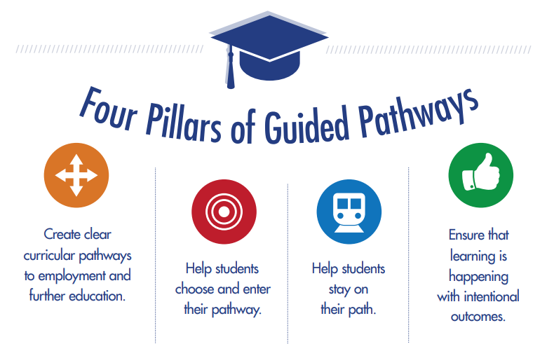
Figure 4 The Four Pillars of Guided Pathways

Internal environment analysis
The internal analysis considered RSCCD’s Comprehensive Master Plan, SAC’s Educational Master Plan, SCC’s Educational Master Plan and Internal Organizational Analysis.

RSCCD’s Goals
RSCCD has developed the following five goals within its Comprehensive Master Plan:

- RSCCD will assess the educational needs of the communities served by RSCCD and will adjust instructional programs, offerings, and support services and will allocate resources as needed to optimize the alignment of students’ needs with services and fiscal resources.

- RSCCD will assess the educational needs of the communities served by RSCCD and then pursue partnerships with educational institutions, public agencies, non-profit organizations, and business/industry/labor to collaboratively meet those needs.

- RSCCD will annually improve the rates of course completion and completion of requirements for transfer, degrees, certificates, and diplomas.

- RSCCD will support innovations and initiatives that result in quantifiable improvement in student access, preparedness and success.

- RSCCD will use a cycle of integrated planning that will demonstrate the effective use of resources.
SAC’s Strategic Plan Areas
SAC’s Educational Master Plan focuses on four main strategic areas, each one made up of multiple goals and objectives:

- Student Achievement

- Budget & Infrastructure (technology, fiscal, facilities)

- Community Awareness and Engagement

- Innovation

SCC’s Goals and Action Items
SCC’s Educational Master Plan focuses on nine main goals, with several action items related to them:

- Support a college culture of academic excellence and personalized education

- Support student success and equity by enhancing the integration of student services, instructional areas, and institutional initiatives

- Focus on student completion of pathways

- Improve communication within the college community

- Support faculty and staff development

- Optimize access to physical, technological, human, and fiscal resources through data-informed, integrated planning and resource allocation processes

- Maintain and enhance the college’s technological infrastructure and facilities

- Strengthen and refine the processes that integrate planning and resource allocation

- Enhance and expand the college’s community presence

Organizational Analysis
ITS Structure
RSCCD maintains a centralized and collaborative Information Technology Services (ITS) department led by the Assistant Vice Chancellor of ITS.

The majority of ITS systems and services are centrally run from the DOC, but the department provides technical services and staffing to SAC, SCC and all of the educational centers and most of the training sites within the district. ITS is responsible for operating and maintaining the physical infrastructure that includes computers, servers, and equipment to support the voice and data network. ITS also ensures data security and privacy, participates in data governance and oversees the core business and communication systems that include email, telephone, student information, financial, and human resources, reporting and related software. Finally, ITS oversees the core operation of public and private facing websites.

The department is divided into four areas, which include Application Systems, Infrastructure, Academic and End User Support at SAC and SCC and the Web team, as shown below.

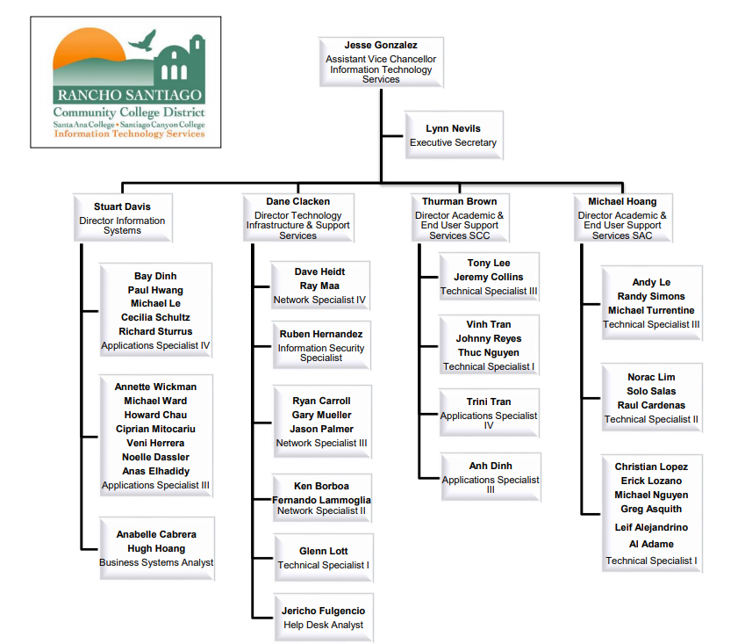
ITS Budget
The primary cost of ITS resources is personnel, followed by the cost of annual technology maintenance agreement renewals that serve the district and its colleges. This cost continues to increase over time due to the expansion of technology solutions, escalator cost increases and inflation. The list of maintenance renewals is regularly shared with the Technology Advisory Group (TAG) for informational purposes and to assess cost saving initiatives, when available. An estimate 10% ongoing budget increase to support technology expenses is required to sustain the technological needs districtwide. The most recent costs are below:

- $2,909,239.33 for FY2019-2020
- $3,390,367.64 for FY2020-2021

There is no official replacement plan that is centrally funded. At this time the colleges are using the local SACTAC and SCCTEC committees to recommend local funding and to determine the priority and locations for computer replacements.

ITS Staffing and number of devices supported
ITS currently has the following resources:
- 5 Management resources
- 1 Executive Secretary
- 11 Technician positions and one vacancy at SAC
- 5 Technician positions at SCC
- 1 Position and 1 vacancy in the Web Team
- 10 Positions and 1 vacancy in the Applications Team
- 2 Business Systems Analysts
- 6 Positions and 1 vacancy in the Infrastructure Team
- 1 Information Security position
- 1 Technician position at DO
- 1 Helpdesk position at DO

The following is the amount of computing devices supported by ITS:

SAC:
Credit Instructional: 2,338
Credit Non-instructional: 1,044
Noncredit Instructional: 738
Noncredit Non-instructional: 128
Total: 4,248
Device to tech ratio: 386:1

SCC:
Credit Instructional: 1,768
Credit Non-instructional: 384
Noncredit Instructional: 324
Noncredit Non-instructional: 38
Total: 2,514
Device to tech ratio: 502:1

DO:
Noncredit Non-instructional: 254
Total: 254
Device to tech ratio: 254:1

Traditional data from Gartner Research pointed to an ideal employee to user ratio of 70:1. A 2008 survey by Robert Half Technology found actual reported ratios of 136:1, while the average “ideal” ratio reported was 82:1. Nowadays, the average employee has more than one device. Assuming that each employee had at least 2 devices, the “ideal” ratio of devices to employees would be 164:1 and the average ratio would be of 272:1. As such, all sites are above the “ideal” ratio. The DO is below the average, while SAC is slightly above and SCC is extremely above the average.

Putting it all together: Developing Strategic Themes for Technology
The environmental analysis clustered items around five common themes: A core theme and four supporting strategic themes.

Student Experience: This is the main strategic theme. All other themes play a supporting role to improving Student Experience. It is no surprise that student success is a common goal across higher education institutions at large as well as the driver to the goals of the College and District strategic and educational master plans. Statewide initiatives including the vision for success and guided pathways were designed to help students succeed. Advancing technology to optimize student experience is critical to achieve student success.

- Standardization: Standardizing processes and technology creates efficiencies across the institution, which result in improved student experience. The guided pathways framework relies heavily on the standardization and alignment of institutional processes between the different areas of student contact. As processes are streamlined through standardization, higher education institutions are faced with the need to implement tools to track student success and measure the efficacy of their framework. Implementing Customer Relationship Management (CRM) systems, products previously tailored to for-profit organizations wanting to standardize and improve customer experience, is now a common initiative in the educational space. The District’s master plan and the Colleges’ educational master plans goals focus on the effective use of resources and enhancing the integration of student services, instructional areas, and institutional initiatives, among other things. Accomplishing these objectives wouldn’t be possible without the efficiencies gained through standardization.

- Data Driven Decision Making: Data is a strategic asset to any institution. Educational institutions collect a significant amount of data from their students, faculty and staff. Having access to this data in the right place at the right time with the proper technology to support it provides a competitive advantage. Advanced technologies such as predictive analytics can guide decision making to get students to stay on the right path or discontinue programs that aren’t generating revenue. The vision for success has very specific goals that are quantifiable and measurable through data analysis. Institutions that master data driven decision making are more likely to be successful at achieving student success.

- Security: Higher education institutions are a large target for security attacks. The vast amount of protected data collected by colleges and universities coupled with the open nature of academic settings requires a fine balance between data privacy, regulation compliance and accessibility. College educational master plans include the enhancement of technological infrastructure as part of their objectives. Ensuring that data and infrastructure is secure is critical to the success of the District and its Colleges.

- Support: Technology has and will continue to play a critical supporting role to help achieve institutional goals. From classroom technology to sustainability, to creating a smart campus to artificial intelligence, technology is the one element that permeates all and facilitates the educational objectives of higher education institutions.

 | External environment
 | EDUCAUSE top 10 Issues, 2019 | Gartner Top 10 2019 Strategic Technologies for Higher Education | ACCJC Accreditation Standards | CCCCO Vision for Success Goals | CCCCO Four Pillars of Guided Pathways
Student Experience | • Student success  • Student-Centered Institution | • Artificial Intelligence Conversational Interface  • Career Software  • Student Cross-Life-Cycle CRM  • Smart Campus  • Wireless Presentation Technologies | • C1  • C2  • C4 | • 1 to 6 (All) | • Create the path  • Enter the path  • Stay on the path  • Ensure learning is happening
Standardization | • Digital Integrations  • Sustainable Funding | • Hybrid Integration Platforms  • Student Cross-Life-Cycle CRM | • C1  • C2  • C4  • C5 | • 5  • 6 | • Create the path  • Enter the path  • Stay on the path  • Ensure learning is happening
Data Driven Decision Making | • Data-Enabled Institution  • Data Management and Governance | • Predictive Analytics  • Artificial Intelligence Conversational Interface  • Student Cross-Life-Cycle CRM  • Smart Campus | • C1  • C2  • C4 | • 1 to 6 (All) | • Enter the path  • Stay on the path  • Ensure learning is happening
Security | • Information Security Strategy  • Privacy | • Next-Generation Security and Risk Management | • C3 | • 1 to 6 (All) | • Create the path  • Enter the path  • Stay on the path  • Ensure learning is happening
Support | • Digital Integrations  • Sustainable Funding  • Integrative CIO  • Higher Education Affordability | • Artificial Intelligence Conversational Interface  • Career Software  • Student Cross-Life-Cycle CRM  • Smart Campus  • Wireless Presentation Technologies  • Hybrid Integration Platforms | • C1  • C3  • C4 | • 1 to 6 (All) | • Create the path  • Enter the path  • Stay on the path  • Ensure learning is happening

 | Internal environment
 | RSCCD's Comprehensive Master Plan Goals | SAC's Educational Master Plan Strategic Areas and Goals | SCC's Educational Master Plan Goals and Action Items
Student Experience | • 1. RSCCD will assess the educational needs of the communities served by RSCCD and will adjust instructional programs, offerings, and support services and will allocate resources as needed to optimize the alignment of students’ needs with services and fiscal resources.  • 2. RSCCD will assess the educational needs of the communities served by RSCCD and then pursue partnerships with educational institutions, public agencies, non-profit organizations, and business/industry/labor to collaboratively meet those needs.  • 3. RSCCD will annually improve the rates of course completion and completion of requirements for transfer, degrees, certificates, and diplomas. | • 1. Student Achievement  • 4. Innovation | • 1. Support a college culture of academic excellence and personalized education  • 2. Support student success and equity by enhancing the integration of student services, instructional areas, and institutional initiatives  • 3. Focus on student completion of pathways  • 7. Maintain and enhance the college’s technological infrastructure and facilities
Standardization | • 4. RSCCD will support innovations and initiatives that result in quantifiable improvement in student access, preparedness and success.  • 5. RSCCD will use a cycle of integrated planning that will demonstrate the effective use of resources. | • 2. Budget & Infrastructure (technology, fiscal, facilities)  • 4. Innovation | • 2. Support student success and equity by enhancing the integration of student services, instructional areas, and institutional initiatives  • 6. Optimize access to physical, technological, human, and fiscal resources through data-informed, integrated planning and resource allocation processes  • 8. Strengthen and refine the processes that integrate planning and resource allocation
Data Driven Decision Making | • 4. RSCCD will support innovations and initiatives that result in quantifiable improvement in student access, preparedness and success.  • 5. RSCCD will use a cycle of integrated planning that will demonstrate the effective use of resources. | • 2. Budget & Infrastructure (technology, fiscal, facilities)  • 4. Innovation | • 3. Focus on student completion of pathways  • 4. Improve communication within the college community  • 5. Support faculty and staff development  • 6. Optimize access to physical, technological, human, and fiscal resources through data-informed, integrated planning and resource allocation processes  • 8. Strengthen and refine the processes that integrate planning and resource allocation
Security | • 1. RSCCD will assess the educational needs of the communities served by RSCCD and will adjust instructional programs, offerings, and support services and will allocate resources as needed to optimize the alignment of students’ needs with services and fiscal resources.  • 2. RSCCD will assess the educational needs of the communities served by RSCCD and then pursue partnerships with educational institutions, public agencies, non-profit organizations, and business/industry/labor to collaboratively meet those needs | • 2. Budget & Infrastructure (technology, fiscal, facilities) | • 6. Optimize access to physical, technological, human, and fiscal resources through data-informed, integrated planning and resource allocation processes  • 7. Maintain and enhance the college’s technological infrastructure and facilities
Support | • 1. RSCCD will assess the educational needs of the communities served by RSCCD and will adjust instructional programs, offerings, and support services and will allocate resources as needed to optimize the alignment of students’ needs with services and fiscal resources.  • 2. RSCCD will assess the educational needs of the communities served by RSCCD and then pursue partnerships with educational institutions, public agencies, non-profit organizations, and business/industry/labor to collaboratively meet those needs | • 2. Budget & Infrastructure (technology, fiscal, facilities)  • 3. Community Awareness and Engagement  • 4. Innovation | • 2. Support student success and equity by enhancing the integration of student services, instructional areas, and institutional initiatives  • 3. Focus on student completion of pathways  • 5. Support faculty and staff development  • 6. Optimize access to physical, technological, human, and fiscal resources through data-informed, integrated planning and resource allocation processes  • 7. Maintain and enhance the college’s technological infrastructure and facilities  • 9. Enhance and expand the college’s community presence

Strategic Themes 2021-2025
Figure 5 Strategic Themes 2021-2025

Goals 2021-2022

Student Experience
  - Provide technology infrastructure capacity and technology services to support on-campus and online student support services. (III.C.1, III.C.2)

  - Provide scalable technologies, services and staff to fully support online education. (III.C.1)

  - Provide technology services to align student experience with the pillars of guided pathways. (III.C.1, III.C.4)

  - Enhance internal and external web resources and mobile applications to improve ease of use for students, programs, services and operations. (III.C.4)

Standardization

  - Establish an ongoing plan to ensure all technology equipment is replaced on a regular basis to support operations, programs, services and district and college missions. (III.C.2)

  - Ensure that all classrooms, labs and study spaces have standardized audio-visual equipment, networking, hardware and software to support collaborations, simulations, presentations, teaching and learning. (III.C.1)

  - Develop and update policies and procedures that guide the use of technology and support teaching and learning processes. (III.C.5)

  - Continuously improve and establish standardized business processes involving technology to enhance institutional operations. (III.C.4)

  - Institutionalize technology planning framework and standardize project management including portfolio management, project intake and project prioritization. (III.C.1)

Data Driven Decision Making

  - Plan regular updates of technology to ensure the quality and capacity to support operations, programs, services and the mission. (III.C.2)

  - Institutionalize data management and data governance for data-informed decision making. (III.C.4)

  - Streamline, encourage and support the use of Business Intelligence reports and reporting tools for the effective use of technology systems. (III.C.1)

Security

  - Continuously improve network infrastructure security processes at all locations where courses, programs, and services are implemented and maintained to assure reliable access, safety, and security. (III.C.3)

  - Develop and maintain information security plans, policies, procedures, practices and projects to assure reliable access, safety, risk management and security compliance at all locations. (III.C.3)

  - Deploy Single Sign-On (SSO) solution for all standardized applications and technology resources to assure reliable access, safety and security at all locations. (III.C.3)

  - Perform ongoing information security training to faculty, staff, students, administrators and external stakeholders. (III.C.3.)

Support

  - Develop and foster Information Technology service excellence, performance feedback and assessment. (III.C.4)

  - Provide training and support for faculty, staff, students, and administrators in the effective use of technology and technology systems related to academic programs, student services and operations. (III.C.4)

  - Improve the effectiveness and efficiency of technology, services and support provided to students, faculty, staff and administrators. (III.C.1)

  - Ensure that technology resources at all locations are implemented and maintained to assure compliance with the American with Disabilities Act (ADA) and all applicable accessibility laws and regulations. (III.C.3)

Goals 2023-2025

Student Experience

  - Promote innovation, provide technology infrastructure capacity and technology services to support on-campus and online student learning and support services. (III.C.1, III.C.2)

  - Provide scalable and innovative technologies, services and staff to fully support online education. (III.C.1)

  - Provide technology services to align student experience with the pillars of guided pathways. (III.C.1, III.C.4)

  - Enhance internal and external web resources and mobile applications to improve ease of use for students, programs, services and operations. (III.C.4)

Standardization

  - Replace and update all technology equipment and software on a regular basis to assure quality and capacity to support operations, programs, services and district and college missions. (III.C.2)

  - Ensure that all classrooms, labs and study spaces have standardized audio-visual equipment, networking, hardware and software to support collaborations, simulations, presentations, teaching and learning. (III.C.1)

  - Develop and update policies and procedures that guide the use of technology and support teaching and learning processes. (III.C.5)

  - Continuously improve and establish standardized business processes involving technology to enhance institutional operations. (III.C.4)

Data Driven Decision Making

  - Regularly update and improve data sets to support system analysis and implementation. (III.C.1)

  - Implement and maintain data management and data governance processes and technology that support data-informed decision making. (III.C.4)

  - Streamline, encourage and support the use of predictive analytics, Business Intelligence and Artificial Intelligence tools for the effective use of technology systems. (III.C.1)

Security

  - Continuously improve network infrastructure security processes, develop and maintain information security plans, policies, at all locations where courses, programs, and services are implemented and maintained to assure reliable access, safety, and security. (III.C.3)

  - Implement and maintain security controls in compliance with the Graham Leach Bliley Act (GLBA). (III.C.3)

  - Deploy Single Sign-On (SSO) solution for all standardized applications and technology resources to assure reliable access, safety and security at all locations. (III.C.3)

  - Perform ongoing information security training for faculty, staff, students, administrators and external stakeholders. Maintain Technology committees apprised on security efforts. (III.C.3.)

Support

  - Develop and foster Information Technology service excellence, performance feedback and assessment. (III.C.4)

  - Provide training and support for faculty, staff, students, and administrators in the effective use of technology and technology systems related to academic programs, student services and operations. (III.C.4)

  - Improve the effectiveness and efficiency of technology, services and support provided to students, faculty, staff and administrators. Promote the use of sustainable technologies. (III.C.1)

  - Ensure that technology resources at all locations are implemented and maintained to assure compliance with the American with Disabilities Act (ADA) and all applicable accessibility laws and regulations. Prioritize technologies and procedures that promote Diversity, Equity, and Inclusion. (III.C.3)

Districtwide Initiatives 2020-2021

Initiative ID # | ITS District Wide Initiatives 2020-2021 | Districtwide Goal #
20-21*01 | Implement an improved enrollment management solution | 21-22*3C
20-21*02 | Support technology solutions that help improve efficiencies and automate manual processes | 21-22*5C
20-21*03 | Online Education Initiative (OEI) Implementation | 21-22*1B
20-21*04 | Improve overall data quality for reporting needs | 21-22*3B
20-21*05 | Optimize student onboarding process | 21-22*1C
20-21*06 | Implement student case management solution with early alert and predictive analytics | 21-22*1C
20-21*07 | Abide by technology replacement cycle for hardware | 21-22*2A
20-21*08 | Refresh or replace end of life software | 21-22*4A
20-21*09 | Establish Colleague patch cycle standards | 21-22*2D
20-21*10 | Standardize Electronic Content Management (ECM) solutions | 21-22*2D
20-21*11 | Implement pilot apps and APIs | 21-22*5C
20-21*12 | Implement a standard reporting solution with ad-hoc capability | 21-22*3A
20-21*13 | Self-Service Implementation | 21-22*1A
20-21*14 | Support CCCCO Integrated Library System (ILS) ExLibris/Alma | 21-22*5C
20-21*15 | Implement a single sign on (SSO) authentication solution for staff and students | 21-22*4C
20-21*16 | Assess functional and technical gaps with SharePoint | 21-22*5C
20-21*17 | Deploy Microsoft’s SCCM centralized solution for computer management and support | 21-22*5C
20-21*18 | Implement new Mobile Device Management solution | 21-22*5C
20-21*19 | Deploy a centralized ITSM solution for ticketing, inventory tracking and project management. | 21-22*5A
20-21*20 | Assess guided pathways scheduling optimization, physical room utilization and enrollment. | 21-22*1C
20-21*21 | Assess solutions for browser security measures to proctor online testing | 21-22*1A
20-21*22 | Implement security solutions to comply with Gramm-Leach-Bliley Act (GLBA) and General Data Protection Regulation (GDPR) | 21-22*4A
20-21*23 | Implement solutions and processes to support Business Continuity (BC) and Disaster Recovery (DR) | 21-22*4B
20-21*24 | Develop Standard Operating Procedures (SOPs) that define and streamline functions and services across ITS teams | 21-22*2D
20-21*25 | Support technology solutions that help facility construction projects | 21-22*5C
20-21*26 | Improve district website mobile experiences and platform stability | 21-22*1D
20-21*27 | Standardize classroom mediation deployments | 21-22*2B
20-21*28 | Provide business process documentation for districtwide technology solutions | 21-22*2C
20-21*29 | Document technology planning standards and ITS project prioritization procedures | 21-22*2E
20-21*30 | Schedule ongoing cybersecurity awareness training sessions. | 21-22*4D
20-21*31 | Develop training materials and schedule training sessions for districtwide technology solutions | 21-22*5B
20-21*32 | Improve Siteimprove accessibility scores for district websites | 21-22*5D
20-21*33 | Foster base system utilization and improve stability while reducing customizations within Ellucian Colleague | 21-22*5C

Districtwide Initiatives 2021-2022
Initiative ID # | ITS District Wide Initiatives 2021-2022 | Districtwide Goal #
21-22*01 | Implement and improve technologies to support enrollment management | 21-22*3C
21-22*02 | Support technology solutions that help improve efficiencies and automate manual processes | 21-22*5C
21-22*03 | Online Education Initiative (OEI) Implementation | 21-22*1B
21-22*04 | Improve overall data quality for reporting needs | 21-22*3B
21-22*05 | Optimize student onboarding process | 21-22*1C
21-22*06 | Implement student case management solution with early alert and predictive analytics | 21-22*1C
21-22*07 | Abide by technology replacement cycle for hardware | 21-22*2A
21-22*08 | Refresh or replace end of life software | 21-22*4A
21-22*09 | Standardize Electronic Content Management (ECM)and digital workflow solutions | 21-22*2D
21-22*10 | Expand use of APIs for system integrations | 21-22*5C
21-22*11 | Improve overall data quality for reporting needs | 21-22*3A
21-22*12 | Self-Service Implementation | 21-22*1A
21-22*13 | Support library technology implementations including Touchnet Integration and EZ Proxy | 21-22*5C
21-22*14 | Support, improve and expand usage for single sign on (SSO) authentication solution for better user experience | 21-22*4C
21-22*15 | Support and improve web Content Management System (CMS) | 21-22*5C
21-22*16 | Deploy SCCM, JAMF centralized solutions for computer and mobile device management and support | 21-22*5C
21-22*17 | Implement and improve technologies that help ITS provide better support | 21-22*5A
21-22*18 | Employ data, cloud, web, mobile and infrastructure technologies to support Guided Pathways | 21-22*1C
21-22*19 | Implement and maintain security solutions and processes to comply with the Gramm-Leach-Bliley Act (GLBA) | 21-22*4A
21-22*20 | Implement solutions and processes to support Business Continuity (BC) and Disaster Recovery (DR) | 21-22*4B
21-22*21 | Develop Standard Operating Procedures (SOPs) that define and streamline functions and services across ITS teams and external technical resources | 21-22*2D
21-22*22 | Support technology solutions that help facility construction projects | 21-22*5C
21-22*23 | Improve district website mobile experience, update website's design and improve web platform stability | 21-22*1D
21-22*24 | Standardize and upgrade classroom mediation systems | 21-22*2B
21-22*25 | Provide business process documentation for districtwide technology solutions | 21-22*2C
21-22*26 | Document technology planning standards and ITS project prioritization procedures | 21-22*2E
21-22*27 | Schedule ongoing cybersecurity awareness training sessions. | 21-22*4D
21-22*28 | Develop training materials and schedule training sessions for districtwide technology solutions | 21-22*5B
21-22*29 | Improve Siteimprove accessibility scores for district websites | 21-22*5D
21-22*30 | Foster base system utilization and improve stability while reducing customizations within Ellucian Colleague | 21-22*5C
21-22*31 | Deploy technologies that support TRI and return to office | 21-22*5C

Districtwide Initiatives 2022-2023
Initiative ID # | ITS District Wide Initiatives 2022-2023 | Districtwide Goal #
22-23*01 | Implement and improve technologies to support enrollment management | 21-22*3C
22-23*02 | Support technology solutions that help improve efficiencies and automate manual processes | 21-22*5C
22-23*03 | Online Education Initiative (OEI) Implementation | 21-22*1B
22-23*04 | Improve overall data quality for reporting needs | 21-22*3B
22-23*05 | Optimize student onboarding process | 21-22*1C
22-23*06 | Implement student case management solution with early alert and predictive analytics | 21-22*1C
22-23*07 | Abide by technology replacement cycle for hardware | 21-22*2A
22-23*08 | Refresh or replace end of life software | 21-22*4A
22-23*09 | Provide technology to ensure students attain class resources and college information in a timely manner. | 21-22*1A
22-23*10 | Expand use of APIs for system integrations | 21-22*5C
22-23*11 | Provide documentation and technology resources to support students who take part in participatory and student governance. | 21-22*5B
22-23*12 | Implement technology that improves Self-Service usability and capabilities | 21-22*1A
22-23*13 | Support library technology implementations including Touchnet Integration and EZ Proxy | 21-22*5C
22-23*14 | Support, improve and expand usage for single sign on (SSO) authentication solution for better user experience | 21-22*4C
22-23*15 | Support and improve web Content Management System (CMS) | 21-22*5C
22-23*16 | Deploy SCCM, JAMF centralized solutions for computer and mobile device management and support | 21-22*5C
22-23*17 | Implement and improve technologies that help ITS provide better support | 21-22*5A
22-23*18 | Employ data, cloud, web, mobile and infrastructure technologies to support Guided Pathways | 21-22*1C
22-23*19 | Implement and maintain security solutions and processes to comply with the Gramm-Leach-Bliley Act (GLBA) | 21-22*4A
22-23*20 | Implement solutions and processes to support Business Continuity (BC) and Disaster Recovery (DR) | 21-22*4B
22-23*21 | Develop Standard Operating Procedures (SOPs) that define and streamline functions and services across ITS teams and external technical resources | 21-22*2D
22-23*22 | Support technology solutions that help facility construction projects | 21-22*5C
22-23*23 | Improve district website mobile experience, update website's design and improve web platform stability | 21-22*1D
22-23*24 | Standardize and upgrade classroom mediation systems | 21-22*2B
22-23*25 | Provide business process documentation for districtwide technology solutions | 21-22*2C
22-23*26 | Develop training materials and schedule training sessions for districtwide technology solutions | 21-22*5B
22-23*27 | Document, standardize and communicate ADA related processes, maintain website accessibility, update accessibility tools. | 21-22*5D
22-23*28 | Foster base system utilization and improve stability while reducing customizations within Ellucian Colleague | 21-22*5C
22-23*29 | Deploy technologies required to support student and employee needs as a result of the pandemic | 21-22*5C

Districtwide Initiatives 2023-2024
Initiative ID # | ITS District Wide Initiatives 2023-2024 | Districtwide Goal #
23-24*01 | Implement and improve technologies to support enrollment management | 23-24*3C
23-24*02 | Support technology solutions that help improve efficiencies and automate manual processes | 23-24*5C
23-24*03 | Support distance education, maintain Online Education Initiative (OEI), continue planning for remote delivery of services | 23-24*1B
23-24*04 | Improve overall data quality for reporting needs | 23-24*3B
23-24*05 | Optimize student onboarding process | 23-24*1C
23-24*06 | Implement and maintain student case management solution | 23-24*1C
23-24*07 | Abide by technology replacement cycle for hardware | 23-24*2A
23-24*08 | Refresh or replace end of life software | 23-24*4A
23-24*09 | Provide technology to ensure students attain class resources and college information in a timely manner. | 23-24*1A
23-24*10 | Expand use of APIs for system integrations | 23-24*5C
23-24*11 | Provide documentation and technology resources to support students who take part in participatory and student governance. | 23-24*5B
23-24*12 | Implement technology that improves Self-Service usability and capabilities | 23-24*1A
23-24*13 | Deploy and support technology to assist with fraud enrollment concerns | 23-24*4B
23-24*14 | Support, improve and expand usage for single sign on (SSO) authentication solution for better user experience | 23-24*4C
23-24*15 | Support and improve web Content Management System (CMS), identify alternatives to existing CMS. | 23-24*5C
23-24*16 | Deploy SCCM, JAMF centralized solutions for computer and mobile device management and support | 23-24*5C
23-24*17 | Implement and improve technologies that help ITS provide better support | 23-24*5A
23-24*18 | Employ data, cloud, web, mobile and infrastructure technologies to support Guided Pathways | 23-24*1C
23-24*19 | Implement and maintain security solutions and processes to comply with the Gramm-Leach-Bliley Act (GLBA) | 23-24*4A
23-24*20 | Implement solutions and processes to support Business Continuity (BC) and Disaster Recovery (DR) | 23-24*4B
23-24*21 | Develop Standard Operating Procedures (SOPs) that define and streamline functions and services across ITS teams and external technical resources | 23-24*2D
23-24*22 | Support technology solutions that help facility construction projects | 23-24*5C
23-24*23 | Improve district website mobile experience, update website's design and improve web platform stability | 23-24*1D
23-24*24 | Standardize and upgrade classroom mediation systems | 23-24*2B
23-24*25 | Provide business process documentation for districtwide technology solutions | 23-24*2C
23-24*26 | Develop training materials and schedule training sessions for districtwide technology solutions | 23-24*5B
23-24*27 | Document, standardize and communicate ADA related processes, maintain website accessibility, update accessibility tools. | 23-24*5D
23-24*28 | Foster base system utilization and improve stability while reducing customizations within Ellucian Colleague | 23-24*5C
23-24*29 | Deploy and support college mobile app replacements and integrating UI technologies for Colleague | 23-24*5C

Districtwide Initiatives 2024-2025
Initiative ID # | ITS District Wide Initiatives 2024-2025 | Districtwide Goal #
24-25*01 | Implement and improve technologies to support enrollment management | 23-25*3C
24-25*02 | Support technology solutions that help improve operational efficiencies, provide cost savings, and automate manual processes | 23-25*5C
24-25*03 | Support distance education, maintain Online Education Initiative (OEI), continue planning for remote delivery of services | 23-25*1B
24-25*04 | Improve overall data quality for reporting needs | 23-25*3B
24-25*05 | Optimize student onboarding process | 23-25*1C
24-25*06 | Implement and maintain student case management solution | 23-25*1C
24-25*07 | Abide by technology replacement cycle for hardware | 23-25*2A
24-25*08 | Refresh or replace end of life software. Upgrade to cloud-based applications when possible. | 23-25*4A
24-25*09 | Provide technology to ensure students attain class resources and college information in a timely manner. | 23-25*1A
24-25*10 | Expand use of APIs for system integrations | 23-25*5C
24-25*11 | Provide documentation and technology resources to support students who take part in participatory and student governance. | 23-25*5B
24-25*12 | Implement technology that improves Self-Service usability and capabilities | 23-25*1A
24-25*13 | Research, implement and maintain technology solutions that support campus, off-campus, and community events which enhance the student experience | 23-25*1A
24-25*14 | Support, improve and expand usage for single sign on (SSO) authentication solution for better user experience | 23-25*4C
24-25*15 | Upgrade web Content Management System (CMS) | 23-25*5C
24-25*16 | Implement and improve technologies that help ITS provide better support | 23-25*5A
24-25*17 | Employ data, cloud, web, mobile and infrastructure technologies to support Guided Pathways | 23-25*1C
24-25*18 | Implement and maintain security solutions and processes to comply with the Gramm-Leach-Bliley Act (GLBA) | 23-25*4A
24-25*19 | Implement solutions and processes to support Business Continuity (BC) and Disaster Recovery (DR) | 23-25*4B
24-25*20 | Develop Standard Operating Procedures (SOPs) that define and streamline functions and services across ITS teams and external technical resources | 23-25*2D
24-25*21 | Support technology solutions that help facility construction projects | 23-25*5C
24-25*22 | Improve district website mobile experience and improve web platform stability | 23-25*1D
24-25*23 | Research, implement and maintain technology solutions that support classroom instruction and learning. | 23-25*2B
24-25*24 | Provide business process documentation for districtwide technology solutions | 23-25*2C
24-25*25 | Develop training materials and schedule training sessions for districtwide technology solutions. Facilitate technology demos for innovative technologies | 23-25*5B
24-25*26 | Research, implement, maintain and educate on accessible technologies and processes to support ADA regulations | 23-25*5D
24-25*27 | Foster base system utilization, remove or rewrite customizations to be SaaS platform ready within Ellucian Colleague. | 23-25*5C
24-25*28 | Improve and deliver consistent user experience on both desktop and mobile environments using Ellucian Experience technology. | 23-25*5C

Implementing the plan: Technology Decision Making and IT Governance
The District’s IT Governance structure, shown below, guides technology planning and operational execution to ensure technology is delivered in support of institutional strategy. The IT Governance Structure creates a feedback loop between technology committees, which are constituency based as part of Participatory Governance and operational workgroups, which are skill based as part of organizational structure. Technology committees produce, update and monitor the execution of the Strategic Technology Plan, while operational workgroups are responsible for executing and prioritizing projects against the Strategic Technology Plan.

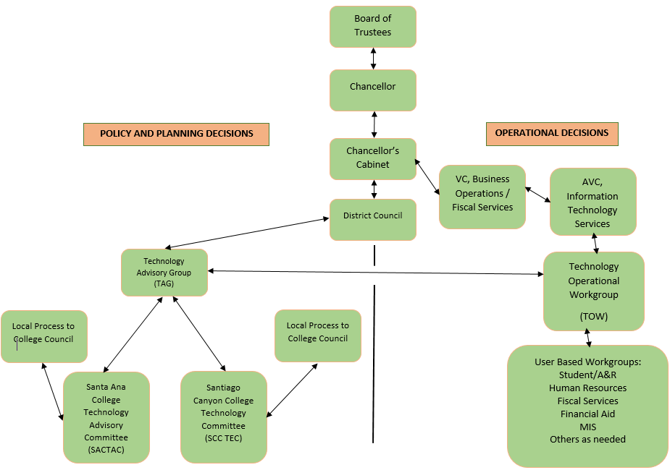

Measuring the success of the Strategic Technology Plan
The Information Technology Services (ITS) Department keeps track of the projects it executes in alignment with the STP. ITS reports biannually to the Technology Advisory Group (TAG) and the Technology Operational Workgroup (TOW) on all the projects successfully completed against the STP. These performance reports, which occur in the middle and at the end of the academic year, inform Participatory Governance and operational workgroups about successes and areas that need to be adjusted to improve and strengthen technology operations.

