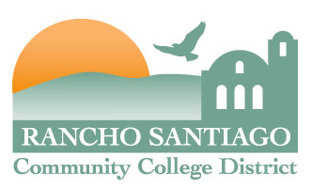
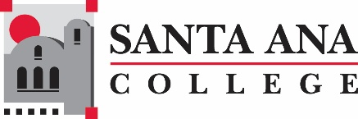


STRATEGIC TECHNOLOGY PLAN
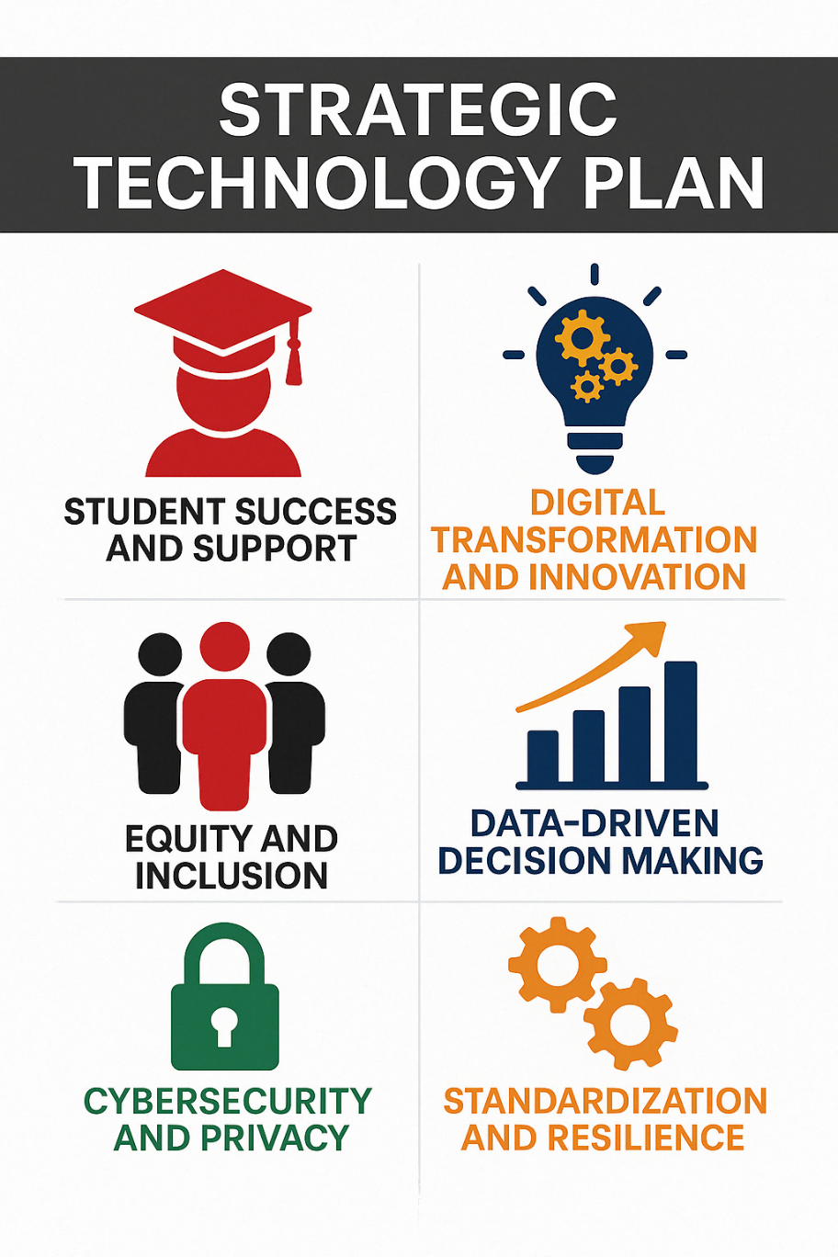

2025 – 2029

Board Approved: June 23, 2025
Last updated by TAG: May 1, 2025

Table of Contents
Purpose 3
Executive Summary 3
Acknowledgements 4
Strategic Technology Plan Taskforce 4
Technology Advisory Group (TAG) Members 4
Technology Advisory Group (TAG) Supporting Resources 4
Strategic Planning Framework 5
1. Strategic Themes 5
2. Goals 5
3. Initiatives 5
4. Projects 5
Using the Strategic Planning Framework to Support the Delivery of Technology Districtwide 6
Using the Strategic Planning Framework to Develop Strategic Technology Plans 7
Strategic Elements Duration and Review 8
Strategic Planning Process 9
External Environmental Analysis 9
Internal Environmental Analysis 10
Putting it All Together: Developing Strategic Themes for Technology 11
Strategic Themes 2025 – 2029 19
Goals 2025 – 2027 19
1. Student Success and Support 19
2. Digital Transformation and Innovation 19
3. Equity and Inclusion 20
4. Data-Driven Decision Making 20
5. Cybersecurity and Privacy 20
6. Standardization and Resilience 21
Districtwide Initiatives 2025 – 2026 21
Implementing the Plan: Technology Decision Making and IT Governance 22
Measuring the Success of the Strategic Technology Plan 23
Appendix A – EDUCAUSE Student Survey 24
Appendix B – The Shape our Tech Future Survey 26
Modifications made as a result of The Shape our Tech Future Survey 32

Purpose
The purpose of the Strategic Technology Plan (STP) is to establish an informed framework for decision making that guides and supports the effective use of technology districtwide for the next four years. The STP considers current internal and external environmental conditions, accreditation standards defined by the Accrediting Commission for Community and Junior Colleges (ACCJC), and the goals and directions established by the District’s Comprehensive Plan, the District Services and Operations Plan, and the colleges’ Comprehensive Educational Plans. These elements are aligned to produce a flexible hierarchical planning structure around current technology trends in support of the institutional mission of the district and its colleges. The STP is a living document, with flexible planning elements that are regularly reviewed and updated to ensure it remains relevant with institutional goals and an evolving technology landscape.

Executive Summary
The internal and external analysis conducted to develop the 2025-2029 Strategic Technology Plan (STP) emphasized the need for community colleges to continue to prioritize overall student achievement, while navigating an environment where higher education institutions face pressure to innovate without sacrificing equity, quality, or academic standards. Global research emphasizes the need to expand the use of emerging technologies, such as virtual reality (VR), augmented reality (AR), and artificial intelligence (AI), to enhance the learning experience. AI is highlighted as a key element in Vision 2030. Cybersecurity also remains a prominent issue, requiring institutions to protect sensitive data and maintain secure systems. Additionally, ongoing faculty development is essential to help educators use new technologies effectively and adapt to hybrid learning models.

Internally, college educational and district plans call for leveraging cutting-edge technology to remove barriers, optimizing technology to increase efficiency, developing streamlined, data-informed, innovative systems, and implementing user-friendly and innovative resources and technology tools.

The STP addresses these key priorities by identifying six strategic themes:

- Student Success and Support
- Digital Transformation and Innovation
- Equity and Inclusion
- Data-Driven Decision Making
- Cybersecurity and Privacy
- Standardization and Resilience

Each theme is supported by targeted goals and actionable initiatives that lead to projects designed to enhance teaching and learning, improve operational efficiency, promote equity in access to technology, and ensure the district remains resilient and future-ready for the next four years. The STP serves as a living document, regularly reviewed and updated, to ensure continuous alignment with institutional goals and responsiveness to a rapidly changing technological landscape.

The success of the STP is measured through biannual and annual performance reports, informing participatory governance and operational workgroups about successes and areas for improvement.

This plan positions the district as a leader in educational excellence, community engagement, and continuous improvement, ensuring that technology is effectively utilized to support the institutional mission and goals.

Acknowledgements
While the development of the Strategic Technology Plan incorporates numerous perspectives, notable recognition is extended to the Strategic Technology Plan Taskforce, the Technology Advisory Group (TAG) and all students and colleagues for their invaluable contributions. We are grateful for their willingness to share their time, knowledge, expertise, and vision in this endeavor.

Strategic Technology Plan Taskforce
Dane Clacken, Director, Technology Infrastructure & Support Services
Jeremy Collins, Technical Specialist III
Jesse Gonzalez, Assistant Vice Chancellor, Information Technology Services
Jennifer Hoeger, Associate Dean, Instruction & Student Services
Ron Gonzalves, Director, Academic and End User Support Services
Scott James, Distance Education Coordinator
Kimberly Perna, Director, Academic and End User Support Services
Jason Sim, Instructor, Computer Information Systems
John Steffens, Director, Student Information Support

Technology Advisory Group (TAG) Members
Robert Bustamante, Student Activities Coordinator
Natasha El-Maissi, Student, Santiago Canyon College
Jesse Gonzalez, Assistant Vice Chancellor, Information Technology Services
Scott James, Distance Education Coordinator
Son Le Graham, Assistant Professor/Counselor
Jimmy Nguyen, Distance Education Services Specialist
Tamia Paulino, Student, Santa Ana College
Giselle Reyes, Student, Santa Ana College
Sergio Rodriguez, Director, Student Information Support
Jason Sim, Instructor, Computer Information Systems
John Steffens, Director, Student Information Support
Pat Weekes, Administrative Secretary/Communications Center

Technology Advisory Group (TAG) Supporting Resources
Dane Clacken, Director, Technology Infrastructure & Support Services
Marvin Gabut, Director, Distance Education/Special Programs
Ron Gonzalves, Director, Academic and End User Support Services
Adam Howard, Director, Enterprise Applications Services
William Nguyen, Chemistry Instructor
Kimberly Perna, Director, Academic and End User Support Services

Strategic Planning Framework
In the Spring of 2019, a districtwide technology planning framework was adopted based on recommendations from representatives of the district Technology Advisory Group (TAG), the Santa Ana College Technology Advisory Committee (SACTAC), and the Santiago Canyon College Technology Committee (SCCTEC). This framework aligns College, District, and Districtwide strategic and educational plans with internal and external environmental conditions to identify common themes that drive the development of the Strategic Technology Plan. The result is a hierarchical planning structure consisting of three layers: Strategic Themes, Goals and Initiatives, and an operational execution layer: Projects. This framework has been utilized once again for the creation of this Strategic Technology Plan. The definitions of these planning layers are outlined below.

Strategic Themes
Strategic Themes are the highest strategic layer in the planning framework. Strategic Themes are intended to be brief, high level, broad, long lasting, all-encompassing and a reflection of the external and internal environments. Strategic Themes are derived from an assessment of the current technology trends in the higher education space and the California Community College System, and the Colleges, District, and Districtwide strategic and educational plans. Developing Strategic Themes is the first step in the planning process.

Goals
Goals are derived from the Strategic Themes. Goals are lower level, more specific and aligned with ACCJC Accreditation Standards. Goals take more of the internal institution environment districtwide into account when developed.

Initiatives
Initiatives are derived from the Goals. Initiatives are low level, specific and based on a more detailed analysis of institutional technology needs. Initiatives can occur at a districtwide or college-specific level. Initiatives represent the bridge from planning to execution. Participatory groups are to involve operational workgroups in the development of initiatives. Operational workgroups are to align project requests with initiatives and prioritize based on their support to the planning framework.

Projects
Projects are the lowest common denominator. The Project layer is not part of the planning process, but rather the result. Projects are derived from initiatives; they are the lowest level items, very specific and cannot be broken up any further. Projects can occur at a districtwide or college-specific level. Projects are generated in several ways, including but not limited to institutional stakeholder requests, external mandates, and statewide initiatives. Districtwide operational workgroups ensure that project requests are properly aligned with the initiatives in the Strategic Technology Plan, that they are prioritized based on their positive institutional impact and that they are timely executed in support of the Strategic Technology Plan.

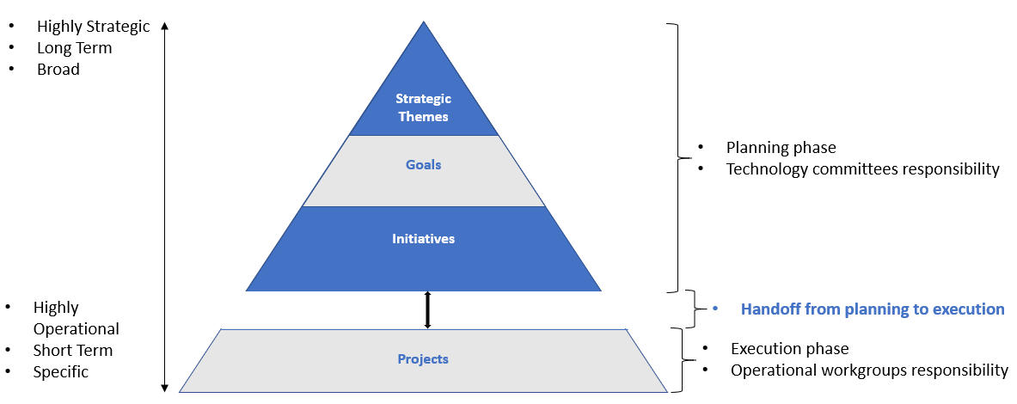Figure 1 Hierarchy of Planning Framework

Using the Strategic Planning Framework to Support the Delivery of Technology Districtwide
The Strategic Planning Framework guides operations to ensure technology is delivered in support of institutional strategy. In addition, the Framework creates a feedback loop between technology committees, who oversee planning, and operational groups, who oversee execution. This occurs by establishing an informational process in which outcomes are communicated between these two groups. Communication is critical to determine the success of the Framework. Planning groups need to be aware of what is being executed, and operational groups need to know what is being planned. This level of communication allows fine tuning to occur, which supports continuous improvement.
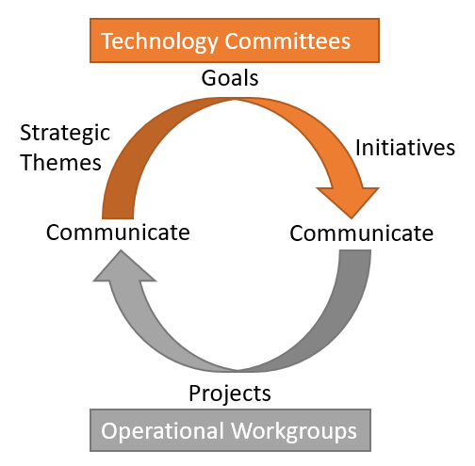
Figure 2 Technology Planning and Execution Cycle

Using the Strategic Planning Framework to Develop Strategic Technology Plans
The Strategic Planning Framework ensures that there is thorough alignment in all Technology Plans districtwide. The same Strategic Themes and Goals are applicable to the Districtwide, SAC and SCC Strategic Technology plans. Districtwide initiatives are captured in the Districtwide Strategic Technology Plan developed by TAG, while College specific initiatives are included in the College Technology plans developed by SACTAC and SCCTEC.
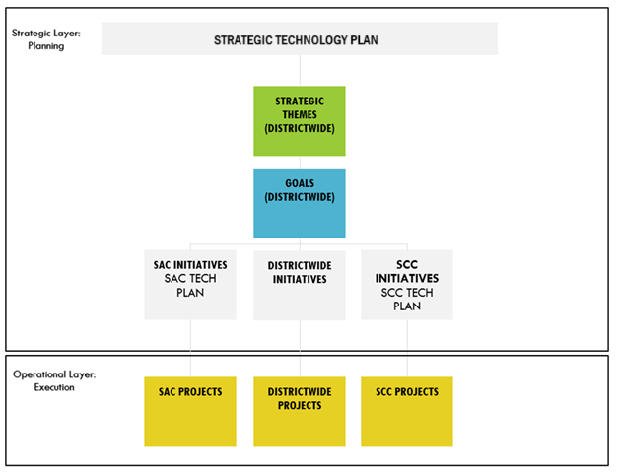
Figure 3 Strategic Technology Plan Structure

Strategic Elements Duration and Review
Strategic Themes, being broader and longer term are designed to last longer than every other element. The timeframes are shortened further down the hierarchy tree:

Strategic Element | Validity Duration | Validity Period | Review Responsibility | Review Period
Strategic Themes | 4 Years | July 1, 2025, to June 30, 2029 | Technology committees | Every 4 years
Goals | 2 Years | July 1st, 2025, to  June 30th, 2027 | Technology committees | Every 2 years
Initiatives | 1 Year | July 1st to June 30th | Technology committees | Every year
Projects | As needed to complete | As needed to complete | Operational Workgroups | Every 30 days

Strategic Planning Process
To start the planning process that would lead to the development of Strategic Themes, an environmental analysis was conducted. The purpose of the analysis is to consider both internal and external factors and identify patterns that can be grouped into broad strategies to guide the technology plan.

External Environmental Analysis
The following sources were used as part of the external environmental analysis:

EDUCAUSE
EDUCAUSE, a nonprofit association and one of the largest communities serving higher education IT professionals, releases multiple reports and studies that highlight trends and issues affecting technology within higher education:
The 2025 EDUCAUSE Top 10 includes the top 10 IT issues affecting higher education, as determined by a panel of experts comprised of IT and non-IT leaders, Chief Information Officers, and faculty members, and then voted on by EDUCAUSE members in an annual survey.
The Horizon Teaching and Learning report in 2024 provides a comprehensive overview of the trends, technologies, and practices expected to shape the future of teaching and learning in higher education.
The 2024 Trend Watch showcases trends, key technologies, and practices within higher education.

Gartner
Gartner, a global research and advisory firm providing information, advice, and tools for leaders in technology and other industries, produced the following research studies:
2024 Top Technology Investments and Objectives for Higher Education: This report provides insights into the most critical outcomes for digital technology investments in higher education.
Snapshot of Innovation in Higher Education: This report provides an overview of key innovation drivers and practices in higher education.
Gartner Predicts 2024: Education Automation, Adaptability, and Acceleration: An analysis of trends and strategic planning assumptions for the education sector.

ACCJC Accreditation Standards
The Accrediting Commission for Community and Junior Colleges established several standards to ensure the quality and effectiveness of institutions. The analysis considered the 2024 ACCJC Accreditation Standards as they relate to the use of technology.

California Community Colleges Chancellor’s Office Vision 2030
Vision 2030 is a collaborative action plan that provides focus, equity, and direction to community colleges. It guides field practice, removes barriers, fosters policy reform, and supports college implementation. And it responds to technological and environmental changes facing our community while holistically addressing the needs of colleges and students. The goals, outcomes, and metrics of Vision 2030 were considered as part of the external analysis.

California Community Colleges Chancellor’s Office 2023 Distance Education Report
The 2023 Distance Education Report analyzes pre- and post- pandemic data (2017-18 to 2022-23) to demonstrate the changes to distance education in California Community Colleges prior to and following the significant impact of COVID-19. Given the technology implications associated with distance education, the data in this report plays a critical role to understand and plan for the changes that California Community Colleges will be required to support.

Gramm-Leach-Bliley Act (GLBA) Part 314 - Standards for Safeguarding Customer Information
Higher education institutions in the US are responsible for complying with the privacy and information security provisions of the Gramm-Leach-Bliley Act (GLBA). Part 314, which implements GLBA sections 501 and 505(b)(2), sets forth standards for higher education institutions to develop, implement, and maintain reasonable administrative, technical, and physical safeguards to protect the security, confidentiality, and integrity of student information.

Strategic Technology Plans from other California Community College Districts
Understanding that California Community Colleges deal with similar issues, it was important to assess the common themes established by recently developed Strategic Technology Plans from other districts. The external environment assessment analyzed the data in the following documents:
Foothill De Anza Community College District Technology Plan 2021-2024
Los Rios Community College District Technology Strategic Plan 2024-2030
MiraCosta Community College District Technology Plan 2022-2027
San Diego Mesa College Technology Strategic Plan 2023-2025

Internal Environmental Analysis
The internal analysis considered the following internal documents:

The RSCCD’s 2024-2032 Comprehensive Plan, which contains four strategic directions that outline the roadmap to position the district as a leader in educational excellence, community engagement, and continuous improvement

SAC’s 2024-2028 Comprehensive Educational Plan, which includes four main goals that intend to position SAC as a premier community college by focusing on student success, community involvement, and continuous improvement.

SCC’s 2024-2032 Comprehensive Educational Plan, which includes five main goals to establish SCC as a leading community college by fostering student success, maintaining standards of excellence, enhancing community engagement, and pursuing continuous improvement.

The 2024-2028 District Services and Operations (DSO) Plan, which aims to align with all other plans in support of institutional mission and objectives carried out by DSO resources.
The 2024FA EDUCAUSE Student Survey, which was conducted at Santa Ana College to identify students’ levels of satisfaction with the technology available to them.

The Shape our Tech Future Survey, which was conducted by the Strategic Technology Plan Task Force to ensure the Strategic Themes and Goals that the group drafted were in line with the expectations and goals of the campus community. The survey was sent to all students and employees districtwide. Common trends identified within the survey responses were used to finalize the Strategic Themes and Goals within the Strategic Technology Plan.

Putting it All Together: Developing Strategic Themes for Technology
The trends identified in the environmental analysis resulted in the development of six common strategic themes:

- Student Success and Support
Providing holistic support services that address the academic, financial, and social needs of students, including mental health support and career planning, is a common trend. Focusing on enhancing the student experience through personalized services and creating a sense of belonging is of key importance. Externally, EDUCAUSE identified personalized services for students as a top ten issue. Internally, district and college plans recognize the need for professional development opportunities that emphasize the effective use of integrated technology for student success and creating an ecosystem that holistically supports the student journey from recruitment to completion. The objective is to serve the whole student and tailor services to their individual needs using technology.

- Digital Transformation and Innovation
Leveraging emerging technologies such as AI, machine learning, generative AI, low-code/no-code development platforms, and distributed cloud to enhance teaching, learning, and administrative processes is central to this theme. It emphasizes modernizing infrastructure to support these technologies and encourages innovative teaching and learning methods, including virtual reality simulations and AI-based course advisors. Externally, Educause includes digital transformation and innovation within its top ten issues, and Gartner anticipates wide adoption of these technologies by 2026. Internally, both Comprehensive Educational Plans refer to the use of cutting-edge technology and the development of virtual spaces. Strategic directions and the DSO plan promote the implementation of innovative systems and technology tools. The aim is to diversify learning opportunities, remove barriers, and improve the overall experience for students and employees.

- Equity and Inclusion
Ensuring equitable access to technology for all students and staff and addressing digital equity barriers is the focus here. The goal is to eliminate barriers to educational opportunities and cultivate an equitable campus culture, creating inclusive learning environments that foster a sense of belonging and engagement for all students. Both internal and external analyses highlighted the importance of equity, inclusivity, and access. Externally, Educause has identified equity and inclusion as one of its top ten issues for 2025, and technology plans from other districts consistently emphasize equitable access to technology. Internally, eliminating barriers to educational opportunities is a common goal across the SAC and SCC Comprehensive Educational Plans. The DSO Plan aims to foster an equitable environment, and supporting accessible virtual spaces is a strategic direction within RSCCD’s Comprehensive Plan.

- Data-Driven Decision Making
Leveraging data, analytics, and AI to inform decision-making processes, increase student success, and improve operational efficiency is crucial. Externally, EDUCAUSE and peer college plans highlight the necessity of empowering institutions through data governance, analytics, and AI. Internally, college and district plans include goals for implementing practices to ensure confidentiality, integrity, and availability of institutional data. The objective is to use accurate and reliable information to guide decision-making and improve educational outcomes.

- Cybersecurity and Privacy
Developing and maintaining a comprehensive information security program that includes risk assessment, implementation of safeguards, regular monitoring and testing, and an incident response plan is essential. Externally, regulatory requirements such as the GLBA and sources including peer technology plans, EDUCAUSE, and Gartner reports demonstrate a critical need for investment in comprehensive information security that is responsive to ever-increasing risks to institutional data. Internally, college and district comprehensive plans emphasize the effectiveness of data-informed processes, centering data security as a critical component of the institution of the future. Standards compliance and proactive defense are crucial to maintain accreditation, protect privacy, and ensure that the institution is future-ready.

- Standardization and Resilience
Implementing sustainable practices in technology operations to reduce environmental impact and promote responsible stewardship aligns with accreditation standards to provide safe and effective physical resources. EDUCAUSE recognizes a rising need for institutional efforts to prepare for and address a growing number and range of risks, ensuring continuity of operations. Improving physical and virtual infrastructure in a modern, sustainable way is a common goal across the colleges’ comprehensive educational plans. The ultimate objective is to enable resilience and effectiveness through sustainable standards.

External Environment
 | EDUCAUSE 2025 Top 10 Issues; 2024 Horizon and Trend Watch reports | Gartner 2024 Predicts, Top Technology Investments and Snapshot of Innovation | ACCJC 2024 Accreditation Standards | CCCCO Vision 2030 and Distance Ed Satisfaction Survey | Strategic Technology Plans from other California CCDs and GLBA Standards
Student Success and Support | Supporting mental health for students and staff.  Increasing demand for anytime, anywhere learning. | Teaching and learning, student experience and success. | 3.2  3.8  3.9 | Ensuring academic and career success for all students. | Providing training and professional development opportunities.
Digital Transformation and Innovation | Smoothing the Student Journey: Using technology and data to improve and personalize student services.  Putting People First: Helping staff adapt, upskill, and thrive in an era of rapid change.  Digital transformation in higher education. | AI, machine learning, generative AI, low-code/no-code development platforms, and distributed cloud are expected to be widely implemented by 2026. | 3.8  3.9 | Significant increase in distance education course sections and student enrollment  Improvement in success rates for distance education.  Growth in the California Virtual Campus Online Course Exchange. | Upgrading and maintaining technology infrastructure.
Equity and Inclusion | Supporting equitable and inclusive learning environments. | Personalized student views, device rentals, digital skills enhancement. | 2.4  3.8  3.9 | Ensuring academic and career success for all students.  Partnering with industry to invest in skilling up workers for socioeconomic mobility. | Providing equitable access to technology.
Data-Driven Decision Making | The Data-Empowered Institution: Using data, analytics, and AI to increase student success.  Use of data to inform decision-making processes. | Increased investments in business intelligence/data analytics. | 3.9  4.2 | Ensuring academic and career success for all students, with a focus on increasing completion rates, baccalaureate attainment, and workforce outcomes. | Improved technology partnerships, and a data-driven culture.
Cybersecurity and Privacy | A Matter of Trust: Advancing institutional strategies to safeguard privacy and secure institutional data. | Increased investments in cybersecurity.  Managing risks and ensuring compliance. | 3.1  3.8  3.9  3.10 | Key actions include increasing access to online programs, expanding flexible term structures, and modernizing system technology infrastructure. | Developing a comprehensive information security program that includes risk assessment, implementation of safeguards, regular monitoring and testing, and an incident response plan.  Enhancing information security and protecting data privacy.
Standardization and Resilience | Institutional Resilience: Contributing to institutional efforts to prepare for and address a growing number and range of risks. | Emphasis on partnering with stakeholders, cost optimization, and integrating knowledge and information. | 3.9  3.10 | Partnering with other systems, agencies, institutions, and community-based organizations to provide students with the necessary academic, financial, and social support. | Establishing a secure and sustainable technology foundation.  Demonstrating responsible stewardship and sustainability.

Internal Environment
 | RSCCD’s 2024-2032 Comprehensive Plan | SAC’s 2024-2028 Comprehensive Educational Plan | SCC’s 2024-2032 Comprehensive Educational Plan | 2024-2028 District Services and Operations (DSO) Plan | 2023FA EDUCAUSE Student Survey and 2025 Shape our Tech Future Survey
Student Success and Support | Strategic Direction 1: Advance RSCCD as a proactive and future-focused institution of educational excellence.  Strategic Direction 4: Leverage diverse funding streams, provide comprehensive professional development, and support accessible virtual spaces and physical facilities. | SAC CEP Goal 1, Objective 1.2: Diversify learning opportunities to meet the needs of students.  SAC CEP Goal 1, Objective 1.3: Promote and expand student support services to address holistic needs of students, particularly from marginalized and/or underrepresented groups. | SCC CEP Goal 1, Objective 1.1: Foster an integrated educational ecosystem that holistically supports the student journey from recruitment to completion.  SCC CEP Goal 5, Objective 5.3: Expand intentional professional development offerings to ensure innovative instructional and support services and to provide advancement opportunities for all employees. | DSO Plan Goal 1, Objective 1.4: Develop and implement a districtwide strategic enrollment management plan.  DSO Plan Goal 2, Objective 2.1: Implement a new Communications Plan and strategy for promoting RSCCD’s innovative  and flexible options for students and stakeholders.
Digital Transformation and Innovation | Strategic Direction 1: Advance RSCCD as a proactive and future-focused institution of educational excellence. | SAC CEP Goal 1, Objective 1.2: Diversify learning opportunities to meet the needs of students.  SAC CEP Goal 3, Objective 3.1: Leverage cutting-edge technology to remove barriers and improve the employee and student experience. | SCC CEP Goal 4, Objective 4.1: Perform a comprehensive evaluation of current technology and optimize utilization to increase efficiency and effectiveness.  SCC CEP Goal 5, Objective 5.1: Develop modern, sustainable, and accessible physical and virtual spaces. | DSO Plan Goal 2, Objective 2.2: Implement strategies to inspire innovative ideas.  DSO Plan Goal 4, Objective 4.2: Implement user-friendly and innovative resources and technology tools for business services, technology planning, and institutional research.
Equity and Inclusion | Strategic Direction 4: Leverage diverse funding streams, provide comprehensive professional development, and support accessible virtual spaces and physical facilities. | SAC CEP Goal 1, Objective 1.1: Eliminate barriers to educational opportunities.  SAC CEP Goal 1, Objective 1.3: Promote and expand student support services to address holistic needs of students, particularly from marginalized and/or underrepresented groups.  SAC CEP Goal 3, Objective 3.1: Cultivate equitable campus culture to support student, faculty, and staff belonging and success. | SCC CEP Goal 4, Objective 4.5: Assess, evaluate, and continue to improve Diversity, Equity, Inclusion, and Accessibility (DEIA) to minimize barriers for the campus community.  SCC CEP Goal 4, Objective 4.4: Evaluate and improve communication that informs and supports employee and student awareness and sense of belonging. | DSO Plan Goal 2, Objective 2.5: Foster a districtwide collaborative and equitable environment through employee education and training.
Data-Driven Decision Making | Strategic Direction 3: Develop streamlined, data-informed, innovative systems and processes. | SAC CEP Goal 3, Objective 3.2: Utilize accurate and reliable disaggregated information to make informed decisions. | SCC CEP Goal 4, Objective 4.3: Ensure data quality and improve reporting structures to drive data-informed decision making. | DSO Plan Goal 4, Objective 4.3: Develop a districtwide data dictionary and institutional dashboard.
Cybersecurity and Privacy | Strategic Direction 1: Advance RSCCD as a proactive and future-focused institution of educational excellence.  Strategic Direction 3: Develop streamlined, data-informed, innovative systems and processes. | SAC CEP Goal 4, Objective 4.1: Improve physical and virtual infrastructure and enhance technology resources. | SCC CEP Goal 4, Objective 4.1: Perform a comprehensive evaluation of current technology and optimize utilization to increase efficiency and effectiveness. | DSO Plan Goal 4, Objective 4.2: Implement user-friendly and innovative resources and technology tools for business services, technology planning, and institutional research.
Standardization and Resilience | Strategic Direction 4: Leverage diverse funding streams, provide comprehensive professional development, and support accessible virtual spaces and physical facilities.  Strategic Direction 3: Develop streamlined, data-informed, innovative systems and processes. | SAC CEP Goal 4, Objective 4.2:  Maximize funding and allocate resources to support equitable  student achievement, sustainable growth, innovation, and  competitive advantage.  SAC CEP Goal 2, Objective 2.1: Identify current and develop potential partnerships to meet  community needs. | SCC CEP Goal 4, Objective 4.1: Perform a comprehensive evaluation of current technology and optimize utilization to increase efficiency and effectiveness.  SCC CEP Goal 2, Objective 2.1: Expand partnerships with K‐12 and universities to provide clear pathways and promote career and educational  opportunities.  SCC CEP Goal 2, Objective 2.2: Build industry partnerships leading students directly into high quality, living wage jobs. | DSO Plan Goal 4, Objective 4.1: Create a holistic system for the contract lifecycle and contract retention.  DSO Plan Goal 6, Objective 6.1: Institutionalize a process to support decisions that impact operations by reassessing the Budget Allocation Model (BAM).  DSO Plan Goal 6, Objective 6.2: Create an administrative structure to support the consistent implementation of national, state, and regional initiatives across the District.

Strategic Themes 2025 – 2029

Goals 2025 – 2027

Student Success and Support
- Provide and enhance technology infrastructure, access, capacity, systems, and services to support on-campus and online student learning, experience, and overall student success. (3.8)

- Provide technology services to align student experience with Vision 2030: A Roadmap for California Community Colleges (3.9)

- Provide training and documentation needed to ensure technology resources facilitate quality teaching and learning across all modalities (3.2), (3.9)

Digital Transformation and Innovation
- Deliver scalable and innovative technologies, including Artificial Intelligence, and cloud computing to comprehensively enhance educational and operational endeavors, ensuring ethical use, mission alignment, and complementing rather than displacing the workforce. (3.9)

- Ensure that all classrooms, labs, study spaces and conference rooms have standardized state-of-the-art audio-visual equipment, networking, hardware, and software to support collaboration, simulations, presentations, teaching, and learning. (3.8), (3.9)

- Continuously improve and establish standardized business processes involving technology to enhance institutional operations. (3.9)

- Improve the effectiveness and efficiency of technology provided to students, faculty, staff, and administrators. (3.8), (3.9)

- Enhance internal and external web resources and mobile applications to improve ease of use for students, programs, services, and operations. (3.9)

Equity and Inclusion
- Ensure that technology resources at all locations are implemented and maintained to assure the highest level of compliance possible with the Americans with Disabilities Act (ADA) and all applicable accessibility laws and regulations. Prioritize technologies and procedures that support Diversity, Equity, Inclusion and Accessibility in line with college equity plans. (2.4), (3.9)

- Promote inclusive learning environments and ensure that students and staff have equitable access to technology, regardless of modality. (3.8), (3.9)

Data-Driven Decision Making
- Facilitate data-informed decision-making by supporting, enhancing, and maintaining modern technologies that store and manage large volumes of data, such as data lakes, data warehouses, and other related technologies. (3.9)

- Implement and maintain data management and data governance processes that support data-informed decision making. (4.2)

- Streamline, encourage and support the use of predictive analytics and business Intelligence tools for the effective use of technology systems, in support of individual and collective insights and expertise. (3.9)

Cybersecurity and Privacy
- To assure reliable access, safety, and security, continuously improve network infrastructure security processes, and develop and maintain information security plans and policies at all locations where courses, programs, and services are implemented and maintained. (3.8), (3.9), (3.1)

- Implement and maintain security controls in compliance with applicable cybersecurity and data privacy standards. (3.8), (3.9), (3.10)

- Perform ongoing information security training and communicate resources for the safe use of technology to faculty, staff, students, administrators, and external stakeholders. Maintain Technology committees apprised of security efforts. (3.9)

Standardization and Resilience
- Update all technology equipment and software on a regular basis, to assure sustainability, quality and capacity to support operations, programs, services and district and college missions. Advocate for ongoing funding to accomplish this goal. (3.9)

- Develop and update policies and procedures that guide the use of technology and support teaching and learning processes. Promote standardization of technology and processes to improve efficiency, achieve cost savings and simplify training. (3.9), (3.10)

- Provide training and support for faculty, staff, students, and administrators in the appropriate use of technology and technology systems related to academic programs, student services and operations. (3.9)

- Develop and foster Information Technology service and support excellence, performance feedback, communication, and assessment. (3.9)

Districtwide Initiatives 2025 – 2026
Initiative ID # | ITS District Wide Initiatives 2024-2025 | Districtwide Goal(s) #
25-26*01 | Implement and improve technologies to support enrollment management | 25-27*4C
25-26*02 | Support technology solutions that help improve operational efficiencies, provide cost savings, and automate manual processes | 25-27*2D
25-26*03 | Support distance education technology and remote delivery of services | 25-27*1A
25-26*04 | Improve overall data access and quality for decision making | 25-27*4A, 25-27*4B
25-26*05 | Evaluate and enhance computing standards to ensure equitable access to technology resources and support, based on current use, available resources, and funding constraints. | 25-27*6A, 25-27*6B
25-26*06 | Implement and manage technology solutions to prevent fraudulent applications, enrollment issues, and unauthorized access to student funding | 25-27*5A, 25-27*5B
25-26*07 | Abide by technology replacement cycle for hardware | 25-27*6A
25-26*08 | Refresh or replace end of life software. Upgrade to cloud-based applications when possible. | 25-27*5B, 25-27*6A
25-26*09 | Develop business process and service documentation. Conduct performance feedback and assessment through surveys and other communication mechanisms. | 25-27*6B, 25-27*6D
25-26*10 | Provide documentation and technology resources to support students who take part in participatory and student governance. | 25-27*6C
25-26*11 | Research, implement and maintain technology solutions that support campus, off-campus, and community events which enhance the student experience | 25-27*1A
25-26*12 | Support, improve and expand usage for single sign on (SSO) authentication solution for better user experience | 25-27*1A, 25-27*5B
25-26*13 | Upgrade web Content Management System (CMS) and maintain web platform stability and access for existing systems | 25-27*2E, 25-27*3A
25-26*14 | Implement and improve technologies that help ITS provide better support | 25-27*5A, 25-27*5D
25-26*15 | Employ data, cloud, web, mobile and infrastructure technologies to support student enrollment, access, persistence, transition, and success | 25-27*1A, 25-27*1B
25-26*16 | Implement and maintain security solutions and processes to comply with the Gramm-Leach-Bliley Act (GLBA) | 25-27*5A, 25-27*5B, 25-27*5C
25-26*17 | Implement solutions and processes to support Business Continuity (BC) and Disaster Recovery (DR) | 25-27*5A, 25-27*5B
25-26*18 | Develop Standard Operating Procedures (SOPs) that define and streamline functions and services across ITS teams and external technical resources | 25-27*2C, 25-27*6D
25-26*19 | Support technology solutions that help facility construction projects | 25-27*1A, 25-27*2B
25-26*20 | Improve district website experience across all platforms. | 25-27*2E
25-26*21 | Research, implement and maintain innovative technology solutions that support teaching and learning. | 25-27*1A, 25-27*2B, 25-27*3B
25-26*22 | Develop training materials and schedule training sessions for districtwide technology solutions. Facilitate technology demos for innovative technologies | 25-27*1C, 25-27*2A, 25-27*6B, 25-27*6C
25-26*23 | Research, implement, maintain and educate on accessible technologies and processes to support ADA and all applicable accessibility regulations | 25-27*3A
25-26*24 | Foster base system utilization, expand use of APIs for system integrations, remove or rewrite customizations to be SaaS platform compliant within Ellucian Colleague. | 25-27*2D, 25-27*6A
25-26*25 | Improve and deliver consistent user experience on both desktop and mobile environments using Ellucian Experience and Self Service technology. | 25-27*2D, 25-27*2E

Implementing the Plan: Technology Decision Making and IT Governance
The District’s IT Governance structure, shown below, guides technology planning and operational execution to ensure technology is delivered in support of institutional strategy. The IT Governance Structure creates a feedback loop between technology committees, which are constituency based as part of Participatory Governance and operational workgroups, which are skill based as part of organizational structure. Technology committees produce, update, and monitor the execution of the Strategic Technology Plan, while operational workgroups are responsible for executing and prioritizing projects against the Strategic Technology Plan.
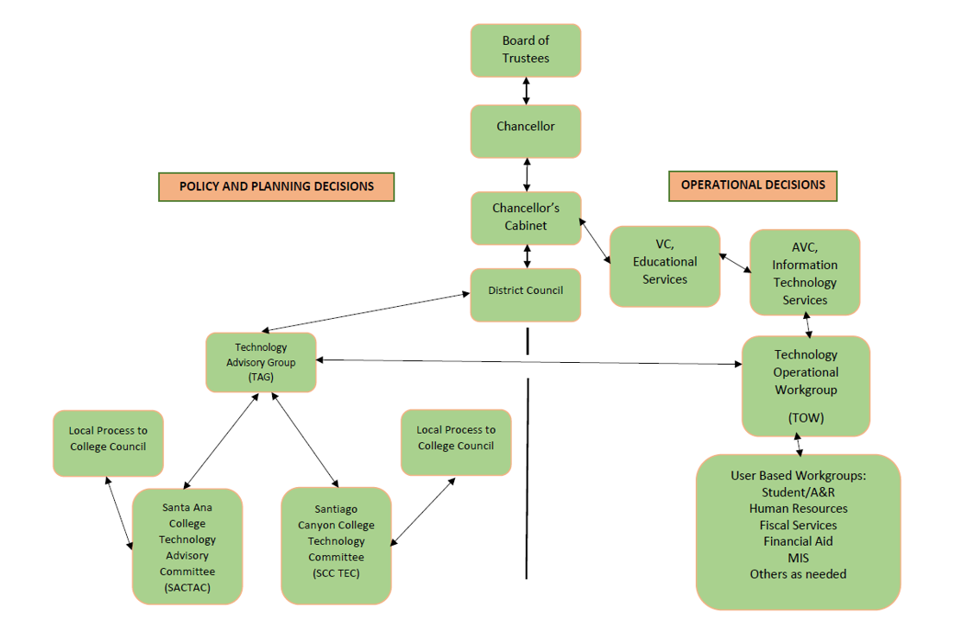Figure 4 RSCCD’s IT Governance Structure

Measuring the Success of the Strategic Technology Plan
The Information Technology Services (ITS) Department tracks the projects it executes in alignment with the STP. ITS reports biannually to the Technology Advisory Group (TAG) and the Technology Operational Workgroup (TOW) and annually to District Council on all the projects successfully completed against the STP. These performance reports, which occur in the middle and at the end of the academic year, inform Participatory Governance and operational workgroups about successes and areas that need to be adjusted to improve and strengthen technology operations.

Appendix A – EDUCAUSE Student Survey
Santa Ana College received 118 responses to the student EDUCAUSE survey in Fall 2024. Overall, approximately 62% of students indicated satisfaction with technology services and over 72% were satisfied with instructors’ use of technology in the classroom.
The survey revealed that generative AI is used extensively by students to assist them in the classroom, with over 97% of respondents indicating use for at least one task. However, students were generally unaware of generative AI resources for services such as tutoring and non-academic support.

Based on the survey results, students were most aware of the following technologies:
- All-in-one mobile app for accessing institutional services and resources: 91.5%
- Tools that suggest how to improve performance in a course: 68.6%
- Self-service registration tools: 67.8%
- Degree-auditing tools: 61.9%

Student awareness was low for the following technologies and services:
- Virtual non-academic support (e.g., counseling, advising) through a bot or artificial intelligence: 34.7%
- Alerts or digital nudges to assist with the timely completion of academic and non-academic tasks: 50.0%
- Tools that provide virtual tutoring through a bot or artificial intelligence: 50.8%
- Guidance about courses you might consider taking in the future: 56.8%

Key Survey Responses:
Course Modality Preferences
- Online: 48.3%
- On-site: 33.9%
- No preference: 0.8%

Satisfaction with Technology Services
- Very satisfied: 38.1%
- Satisfied: 23.7%
- Neutral: 21.2%
- Dissatisfied: 5.1%
- Very dissatisfied: 8.5%
- I don't know: 3.4%

Use of Generative AI in Courses
- Brainstorming: 80.5%
- Drafting papers/essays: 84.7%
- Drafting slides/presentations: 87.3%
- Writing code: 86.4%
- Outlining/organizing: 90.7%
- Refining ideas/questions: 97.5%
- Analyzing data: 92.4%
- Writing emails: 96.6%
- Taking quizzes/tests: 97.5%
- Submitting generated material: 87.3%

Quality of Internet/Wi-Fi on Campus
- Satisfied: 21.2%
- Neutral: 25.4%
- Very satisfied: 19.5%
- Dissatisfied: 5.9%
- Very dissatisfied: 7.6%
- I don't use internet/Wi-Fi on campus: 0.8%
- I don't know: 0.8%

Access to Reliable Internet/Wi-Fi on Campus
- Easy: 31.4%
- Neither difficult nor easy: 25.4%
- Very easy: 18.6%
- Difficult: 10.2%
- Very difficult: 3.4%
- I don't know: 0.8%

Satisfaction with Instructors' Use of Technology
- Very satisfied: 38.1%
- Satisfied: 34.7%
- Neutral: 14.4%
- Dissatisfied: 3.4%
- Very dissatisfied: 5.9%
- I don't know: 3.4%

Awareness of Online Student Success Tools Provided
- Degree-auditing tools: 61.9%
- Guidance about future courses: 56.8%
- Tools to improve performance: 68.6%
- Virtual tutoring: 50.8%
- Virtual nonacademic support: 34.7%
- Self-service registration tools: 67.8%
- All-in-one mobile app: 91.5%

Appendix B – The Shape our Tech Future Survey
A districtwide survey was sent out to all students, faculty, and staff with the initial draft for the Strategic Themes and the Goals. Overall, the great majority of respondents strongly agreed that the goals and themes aligned strongly with the institution’s needs and vision. The Strategic Technology Plan Taskforce reviewed all survey comments, and adjusted the goals, themes, and initiatives when it found common recommendations or areas of concern. The survey results follow.

Strategic Theme 1: Student Success and Support
Goal a: Provide and enhance technology infrastructure, access, capacity, systems, and services to support on-campus and online student learning, achievement, experience, and overall student success.
Goal b: Provide technology services to align student experience with Vision 2030: A Roadmap for California Community Colleges.
Goal c: Provide training and documentation needed to ensure technology resources facilitate quality teaching and learning across all modalities.

Options | Number of Responses | Total Percentage of Respondents
Strongly Agree – The goals align perfectly with our institution’s needs and vision. | 133 | 72%
Agree – The goals are on the right track but could use minor adjustments. | 48 | 26%
Disagree – The goals need significant revisions to meet our needs. | 4 | 2%
Strongly Disagree – The goals do not reflect our priorities or vision. | 1 | 1%

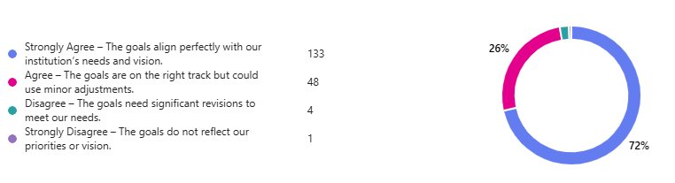

Strategic Theme 2: Digital Transformation and Innovation
Goal a: Deliver scalable and innovative technologies, including Artificial Intelligence, and cloud computing to comprehensively enhance educational and operational endeavors.
Goal b: Ensure that all classrooms, labs, study spaces and conference rooms have standardized state of the art audio-visual equipment, networking, hardware, and software to support collaboration, simulations, presentations, teaching, and learning.
Goal c: Continuously improve and establish standardized business processes involving technology to enhance institutional operations.
Goal d: Improve the effectiveness and efficiency of technology provided to students, faculty, staff, and administrators.
Goal e: Enhance internal and external web resources and mobile applications to improve ease of use for students, programs, services, and operations.

Options | Number of Responses | Total Percentage of Respondents
Strongly Agree – The goals align perfectly with our institution’s needs and vision. | 127 | 68%
Agree – The goals are on the right track but could use minor adjustments. | 43 | 23%
Disagree – The goals need significant revisions to meet our needs. | 13 | 7%
Strongly Disagree – The goals do not reflect our priorities or vision. | 3 | 2%

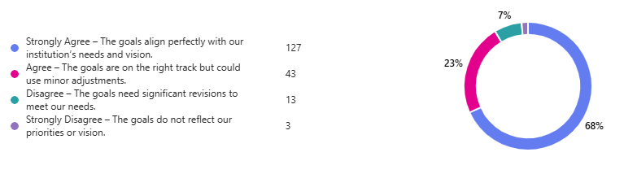

Strategic Theme 3: Equity and Inclusion
Goal a: Ensure that technology resources at all locations are implemented and maintained to assure compliance with the American with Disabilities Act (ADA) and all applicable accessibility laws and regulations. Prioritize technologies and procedures that promote Diversity, Equity, and Inclusion.
Goal b: Promote inclusive learning environments and ensure that students and staff have equitable access to technology, regardless of modality.

Options | Number of Responses | Total Percentage of Respondents
Strongly Agree – The goals align perfectly with our institution’s needs and vision. | 146 | 78%
Agree – The goals are on the right track but could use minor adjustments. | 28 | 15%
Disagree – The goals need significant revisions to meet our needs. | 7 | 4%
Strongly Disagree – The goals do not reflect our priorities or vision. | 5 | 3%

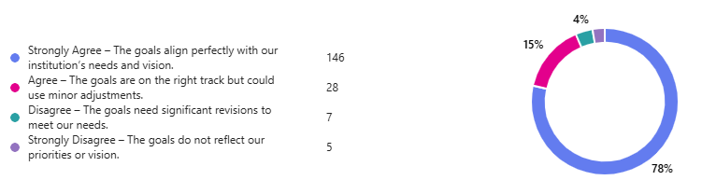

Strategic Theme 4: Data-Driven Decision Making
Goal a: Facilitate data-informed decision-making by supporting, enhancing, and maintaining data lakes, data warehouses, and other related technologies.
Goal b: Implement and maintain data management and data governance processes that support data-informed decision making.
Goal c: Streamline, encourage and support the use of predictive analytics and business Intelligence tools for the effective use of technology systems.

Options | Number of Responses | Total Percentage of Respondents
Strongly Agree – The goals align perfectly with our institution’s needs and vision. | 122 | 66%
Agree – The goals are on the right track but could use minor adjustments. | 52 | 28%
Disagree – The goals need significant revisions to meet our needs. | 7 | 4%
Strongly Disagree – The goals do not reflect our priorities or vision. | 5 | 3%

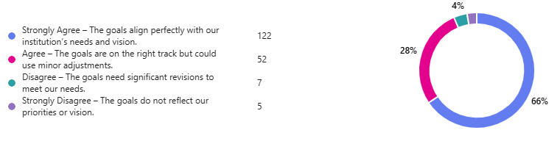

Strategic Theme 5: Cybersecurity and Privacy
Goal a: Continuously improve network infrastructure security processes, develop and maintain information security plans, policies, at all locations where courses, programs, and services are implemented and maintained to assure reliable access, safety, and security.
Goal b: Implement and maintain security controls in compliance with the Graham Leach Bliley Act.
Goal c: Perform ongoing information security training and communicate resources for the safe use of technology to faculty, staff, students, administrators, and external stakeholders. Maintain Technology committees apprised on security efforts.

Options | Number of Responses | Total Percentage of Respondents
Strongly Agree – The goals align perfectly with our institution’s needs and vision. | 147 | 79%
Agree – The goals are on the right track but could use minor adjustments. | 34 | 18%
Disagree – The goals need significant revisions to meet our needs. | 4 | 2%
Strongly Disagree – The goals do not reflect our priorities or vision. | 1 | 1%

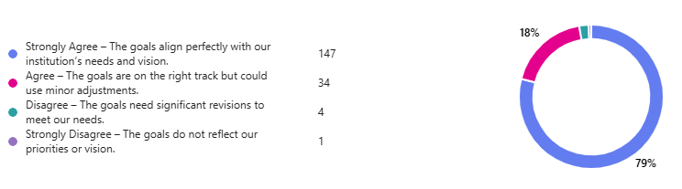

Strategic Theme 6: Standardization and Resilience
Goal a: Update all technology equipment and software on a regular basis, to assure sustainability, quality and capacity to support operations, programs, services and district and college missions.
Goal b: Develop and update policies and procedures that guide the use of technology and support teaching and learning processes.
Goal c: Provide training and support for faculty, staff, students, and administrators in the appropriate use of technology and technology systems related to academic programs, student services and operations.

Options | Number of Responses | Total Percentage of Respondents
Strongly Agree – The goals align perfectly with our institution’s needs and vision. | 142 | 76%
Agree – The goals are on the right track but could use minor adjustments. | 37 | 20%
Disagree – The goals need significant revisions to meet our needs. | 5 | 3%
Strongly Disagree – The goals do not reflect our priorities or vision. | 2 | 1%

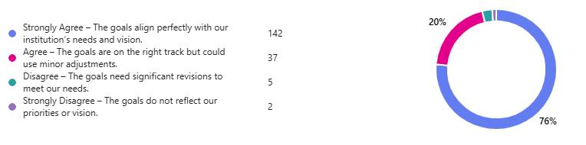

Modifications made as a result of The Shape our Tech Future Survey

The Strategic Technology Plan Taskforce reviewed the feedback provided on the survey and made the adjustments below to ensure further alignment. These changes reflect the collective input of the survey respondents, ensuring the Strategic Technology Plan is more comprehensive, inclusive, and aligned with the institution's goals and values.

Theme 1: Alignment with Vision 2030

Feedback: Suggestions to make the theme briefer and clarify alignment with Vision 2030.
Changes: Updated language to be more concise and clearly align with Vision 2030.

Theme 3: Diversity, Equity, Inclusion, and Accessibility (DEIA)

Feedback: Emphasis on accessibility and realistic goals considering funding and vendor compliance.
Changes: Added accessibility to DEIA, corrected ADA terminology, and elaborated on DEIA goals.

Theme 4: Data-Informed Decision Making

Feedback: Concerns about understanding data lakes, ethical use of data, and human engagement.
Changes: Explained data lake and warehouse technology, emphasized ethical use of data, and integrated human engagement into decision-making processes.

Theme 5: Security and Legislative Acts

Feedback: Clarification needed on legislative acts and inclusion of customer information.
Changes: Removed legislative act references, added a more generic data privacy statement, and included customer information in security controls.

Theme 6: Standardization and Communication

Feedback: Suggestions for handling one-off requests and improving communication.
Changes: Added standardization of technology and processes, and formalized communication practices.

Initiatives and Projects:

Feedback: Various suggestions on technology access, implementation efficiency, and support for Apple products.
Changes: Added initiatives for evaluating computing standards, discussing technology training during student orientation, assessing tech support needs, and advocating for funding.
Training and Support:

Feedback: Need for more training for faculty, staff, and students, and addressing fraudulent enrollment.
Changes: Added training initiatives, emphasized ADA access for employees, and included measures to combat fraudulent enrollment.
Ethical Use of AI:

Feedback: Concerns about AI's impact on staff positions, ethical use, and alignment with values.
Changes: Updated goals to ensure responsible AI use, provide training, and align AI implementation with institutional values.

Refer to Appendix A
Refer to Appendix B

